Functional Areas of a Business - A Note of Caution!
Now we have some ideas about what each functional area does we need to urge a note of caution:
All businesses will carry out each of these functions but...
- Not every business will have a separate department that is responsible for each function
- Very large businesses will have specialist staff in each department and these departments could be spread across the globe!
- Small businesses may have one or two people who try and do everything!
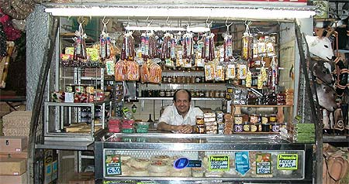

Different businesses, therefore, will manage their functions in different ways so do not expect every business to do exactly the same thing.

Look at the mind map below. The images on the map might give you a clue but can you come up with other ideas about what each part of a business does?

Functional areas of a business – what does each functional area do?
Each of the functions of a business has an important part to play in ensuring the business is run properly.

Kettleby Foods is a part of the Samworth Brothers Group. You may not have heard of Kettleby Foods but your have probably eaten one of their products! Kettleby Foods manufacture ready meals such as Cottage Pie, Lancashire Hotpot, Beef Stew and Dumplings and others. The market for ready meals is around £1.35 billion and growing. Ready meals as a part of the food market has grown in recent years as people seek to adjust to the demands of busy lifestyles. With many families having both parents working the availability of well-prepared and tasty ready meals fills an important sector of the market.

Each of the following tasks are carried out by Kettleby Foods, but which functional area does each belong to? Sort the statements under the correct functional area - Human Resources, Customer Services, Marketing/Sales, Research and Development, Administration/IT Support, Production/Operations and Finance and Accounts. For example, the first statement, 'Interviewing a member of staff for promotion' would go in the Human Resources pile.

- Interviewing a member of staff for promotion
- Preparing a report on daily sales figures
- Meeting a sales representative from a supplier
- Ordering a supply of potatoes
- Preparing a report on the health and safety policy
- Repairing a faulty piece of equipment on the production line
- Chefs testing out a new fast meal idea
- Staff packing the finished product into boxes
- Planning how many shepherds pies need making next week
- Working with a trade union to solve a problem about a member of staff who is consistently late to work
- Doing a survey of customers to find out their views of different products
- Paying local authority business rates
- Ordering supplies of paper for the photocopier in the accounts department
- Investigating a new piece of software to monitor quality of pies
- Dealing with a complaint from an employee that the production areas are too cold
- Arranging the payment of the annual bonus to staff
- Stripping down and cleaning production equipment each night
- Taking the minutes of a meeting of the senior managers
- Sending a fax to a meat supplier in Ireland
- Monitoring cars and other vehicles entering the factory site
- Planning a different way of producing the range of chicken and broccoli pies
- Discussion of prices for the 'Healthy Living' range with Tesco
- Dealing with a complaint from Tesco about the quality of cumberland pies
- Ordering new sets of overalls for the production workers

CUSTOMER SERVICE
MARKETING/SALES

FUNCTIONAL AREAS AT KETTLEBY FOODS

FINANCE AND ACCOUNTS
RESEARCH AND DEVELOPMENT
ADMINISTRATION/IT
HUMAN RESOURCES
PRODUCTION/OPERATIONS

