NAME:

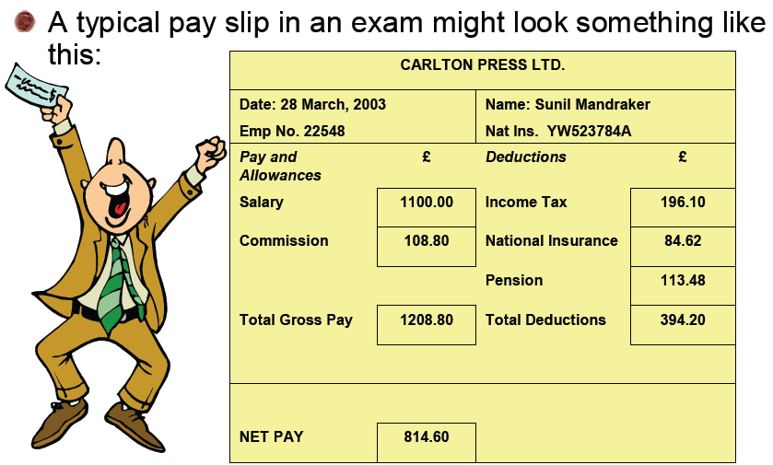

DATE:  EMP NO: | NAME:  NAT INS:
Pay and allowances £ | Deductions £

HOMEWORK: Complete the following wage slip
NAME:
Scenario 1

Mrs P Patel works as a Sales Representative for Avon Ltd. Her job is to visit local businesses that would be potential customers of Avon Ltd and using her selling skills encourage as many of them to buy Avon products.
She is paid a weekly wage and is due to be paid on Friday 26 February 2008.
Complete Mrs Patel’s wage slip using the template opposite. Use the following information and calculate her total gross pay, total deductions and total net pay.
National Insurance No: NH3456784C
Employee No: 2367
Basic Wage: £315
Commission: £79
Income tax: 10% of her gross pay
National Insurance: £90
Pension: £75

DATE:  EMP NO: | NAME:  NAT INS:
Pay and allowances £  Basic wage  Commission  GROSS PAY | Deductions £  Income Tax  National Insurance  Pension  Total deductions
NET PAY

2. Explain the difference between Gross pay and Net Pay.

3. Explain why it would be beneficial to use a spreadsheet to draw up wages.

Scenario 2

Other workers at Twoey Toys Ltd are outlined below.
Mr T Brown, National Insurance No: NH345678B, Employee No: 4568, Basic Wage: £210, Commission: £60, Income tax: 10% of his gross pay, National Insurance: £40, Pension: £25
Mrs C Robinson, National Insurance No: NH225678B, Employee No: 4569, Basic Wage: £210, Commission: £50, Income tax: 10% of his gross pay, National Insurance: £30, Pension: £25
Ms P Stevenson, National Insurance No: NH344578B, Employee No: 4570, Basic Wage: £210, Commission: £66, Income tax: 10% of his gross pay, National Insurance: £43, Pension: £34
Mr D Davidson, National Insurance No: NH345629B, Employee No: 4571, Basic Wage: £210, Commission: £54, Income tax: 10% of his gross pay, National Insurance: £33, Pension: £25
Ms R Wilson, National Insurance No: NH345118B, Employee No: 4572, Basic Wage: £210, Commission: £60, Income tax: 10% of his gross pay, National Insurance: £40, Pension: £25
Mr W Quinn, National Insurance No: NH335568B, Employee No: 4573, Basic Wage: £210, Commission: £44, Income tax: 10% of his gross pay, National Insurance: £55, Pension: £30

Scenario 1

James Smith works as a Sales Representative for Twoey Toys Ltd. His job is to visit local businesses that would be potential customers of Twoey Toys and using his selling skills encourage as many of them to buy Twoey Toys products.
He is paid a weekly wage and is due to be paid on Friday 9th January 2008.
Complete Mr Smith’s wage slip using the template given to you. Use the following information and calculate his total gross pay, total deductions and total net pay.
National Insurance No: NH2546784C
Employee No: 4567
Basic Wage: £210
Commission: £80
Income tax: 10% of his gross pay
National Insurance: £45
Pension: £30
Once you have completed this by hand, create a spreadsheet to work these calculations out for you. Check that your formulas are correct.

