One of the most famous 100-metre sprints of all time took place in New York in June of 1991. The winner, Leroy Burrell, set the world record for the distance in 9.90 seconds . . . but he was actually slower than the runner-up.
Even though Burrell crossed the finish line first, close analysis of the race revealed that Carl Lewis had been faster over the distance.
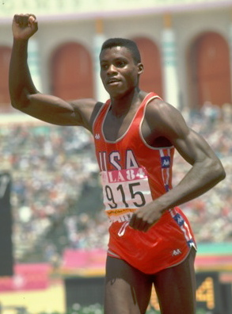
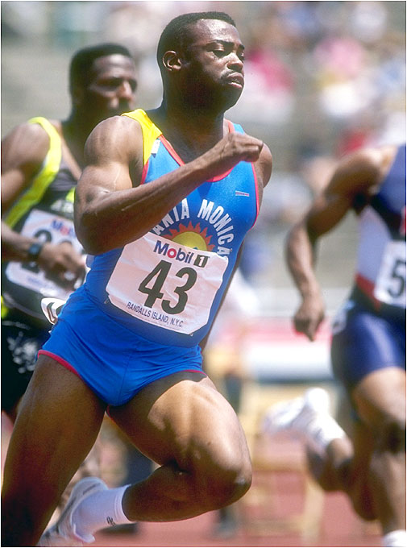
Leroy Burrell
Race Time: 9.900 sec
Reaction Time: 0.117 sec
Carl Lewis
Race Time: 9.930 sec
Reaction Time: 0.166 sec

