In Serif DrawPlus most of the tools you need are in the QuickBox menu. Ask your teacher if you don’t know where this is.
Big Top Circus needs a logo creating for some posters and free key rings, badges and balloons. Copy the design below for them
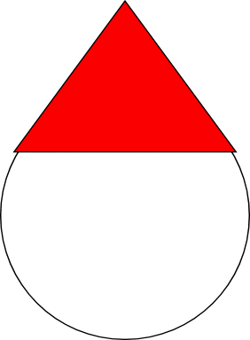  Use the QuickEllipse and QuickPolygon tools to create the face and hat  Using the ‘Fill’ colour chart select the colours you want  HINT: to get a perfect circle hold down the ‘Ctrl’ key while you draw it  HINT: use the node handle to change the pentagon to a triangle | Now add features to the face – eyes, nose & mouth  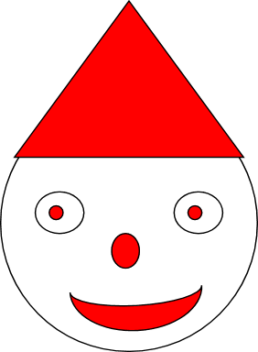  HINT: eyes aren’t circular so use an ellipse shape  HINT: the mouth is a curved shape so use the QuickMoon tool, then rotate it
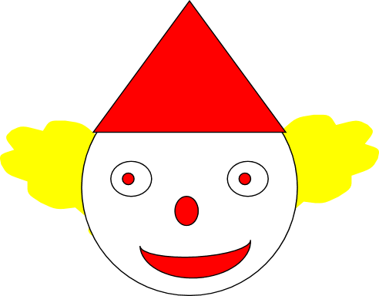  To do the hair we cheat a bit (but not much)  Insert a QuickThought shape – like this one:  Change the colour to yellow  Use the Arrange > Order objects and select Send to back  Align the shape correctly | 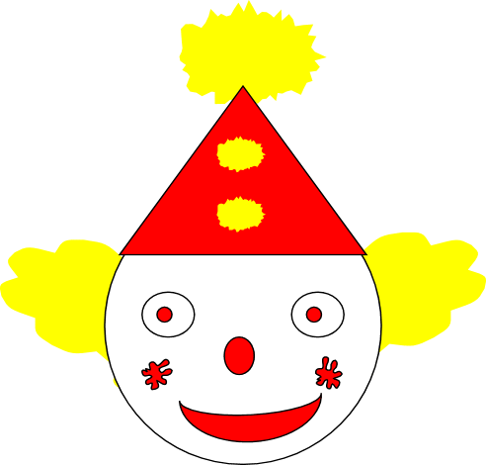  For the pom-poms on the clowns hat use the QuickEllipse tool  To create the jagged edge use the Roughen Tool from the tool bar on the left  The design on the cheeks is done using the QuickSplats tool from the QuickBox

