Protecting a business idea - Scrabulous under fire
Saturday, August 02, 2008
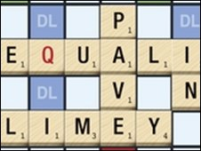
The developers of the popular Facebook application Scrabulous have suspended the game for some users following legal action by toy maker Hasbro.
The application has been disabled for users in the US and Canada.
Hasbro, the makers of Scrabble, are suing the Calcutta-based founders of Scrabulous, claiming they are infringing its copyright and trademark.
Hasbro had asked Facebook to block access following the launch of its own official version of Scrabble.
A spokeswoman for Facebook told the BBC that the final decision to suspend the game was made by the developers, not the site itself.
Defence campaign
Scrabulous has been one of the most popular applications on Facebook, regularly racking up more than 500,000 users each day.
Fans have mounted a vigorous defence campaign since the joint owners of Scrabble, Mattel and Hasbro, announced their intention to sue the Facebook developers back in January.
In a statement, Facebook said that "games are an important part of the social experience on Facebook" and they hope that the dispute will not discourage other developers from testing new ideas.
"We're disappointed that Hasbro has sought to draw us into their dispute," it said. "Nevertheless, we have forwarded their concerns to Scrabulous and requested their appropriate response."

Protecting a business idea - Bratz hit by copyright damages
Toymaker Mattel has been awarded multi-million dollar damages in a copyright case against the maker of the popular Bratz dolls, MGA Entertainment.
A California jury made the award after a court ruled that the creator of Bratz dolls, Carter Bryant, came up with the idea while he was working for Mattel. The payout is thought to be at least $40m (£22m) but Mattel, which makes Barbie, had asked for about $2bn. The large-headed, multi-ethnic, urban fashion dolls became a bestseller. The dolls are estimated to be making profits of about $500m a year for MGA.
Settlement
Mattel, the world's biggest toymaker, won the case in July after claiming that the name and design of Bratz dolls were based on drawings by Carter Bryant made while he was under a contract that entitled Mattel to his designs.
MGA had argued that although Mr Bryant worked for Mattel between 1995 and April 1998 and then again from January 1999 to September 2000, the idea had come to him in the gap between his two stints. Mr Bryant himself reached a confidential settlement with Mattel on the eve of the trial. MGA had argued that the company had built the value of the doll with its own additions, branding and packaging. The jurors had been told they could decide whether MGA should only be held responsible for profits from the first four Bratz dolls - which came from Bryant's drawings - or the gains from all subsequent dolls and related products.
Barbie has been losing market share since Bratz came on the market. Mattel's three-monthly results, released on Friday, showed a further fall. Barbie's worldwide gross sales fell 6% between April and June 2008 as the company's net profit fell 48% to $11.8m. Barbie sales in the US were down 21%.
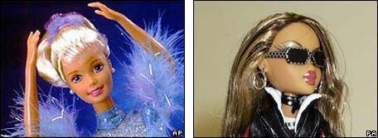

Barbie Bratz

Protecting a business idea - the irn-bru way
Tuesday, May 26, 2009
by Jim Riley
Print Email RSS Tweet This!
Here is a great way of illustrating the concept of protecting a business idea - without resorting to the tired and boring descriptions of patents, copyright and trademarks. Step forward the maker of Irn-Bru
An article on the BBC Scotland website describes how Robin Barr, the Chairman of the drinks firm AG Barr is stepping down from this role on the Board. But that’s not all he is stepping down from.
For Mr Barr is ”one of only two people in the world who knows the secret recipe for the best-selling Irn Bru drink and the two never travel on the same plane.”
The article describes how “once a month the essences for the drink are personally mixed by Robin Barr in a sealed room at the company’s headquarters in Cumbernauld. The 32 different ingredients are combined in a huge vat, which mixes 8,000 litres at a time.”
A great example of how to protect intellectual property and prevent the competition from copying a good idea.
For good measure, you might also want to show students the latest Irn-Bru advert, which is an engaging one-minute spoof of High School Musical. Very amusing:

