**Conservative Plate Boundary**

At conservative plate margins plates slide past each other. The plates rub against a crack in the ground called a fault. A famous example of this is the San Andreas fault. This is happening between the Pacific and North American plates. Sometimes the plates get stuck along fault, pressure builds, until the plates break free – causing an earthquake. As the plates are only rubbing together, no rock gets melted so there is no magma produced.

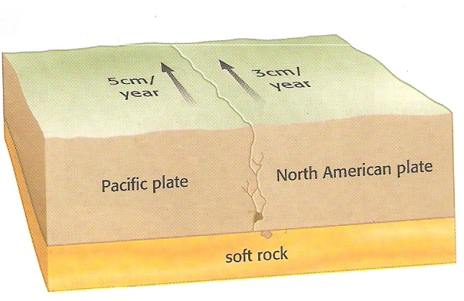

**Collision Plate Boundary**

At a collision plate boundary two continental plate are forced into each other. This is happening between the Indo-Australian and Eurasian plates. Neither plate gets forced downwards so they press together creating a massive amount of pressure. The plates eventually get folded upwards creating fold mountain like Himalayas. This is still happening in the Himalayas, producing lots of earthquakes.

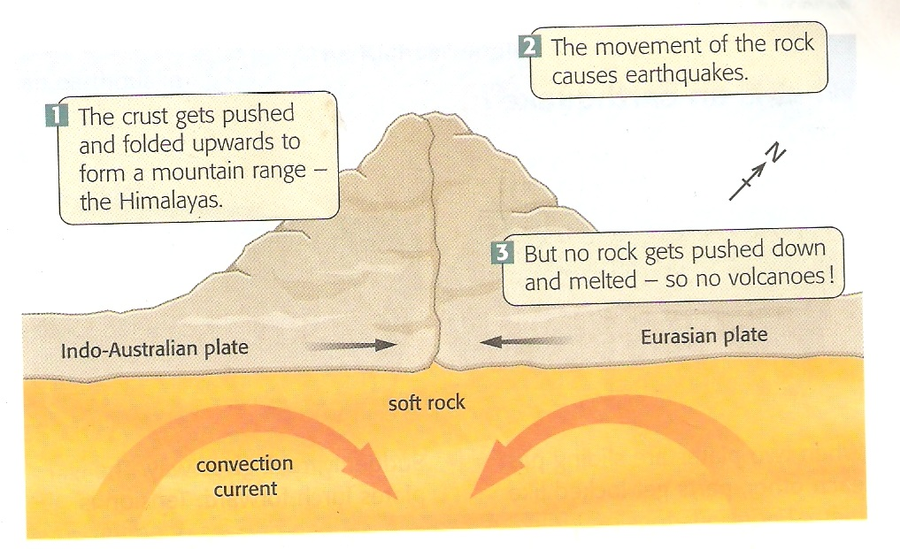

**Constructive Plate Boundary**

At constructive plate boundaries tectonic plates move apart. This currently happening between the Eurasian and North American plate. The plates are pulled apart by convection currents in the mantle, creating a gap. The hot magma rises between the plates forming small volcanoes on the ocean floor. The volcanoes harden into a rock called basalt, which forms the new ocean floor. These volcanoes form a long ridge, called an ocean ridge. An example is the mid-Atlantic ridge between the Eurasian and North American plate.

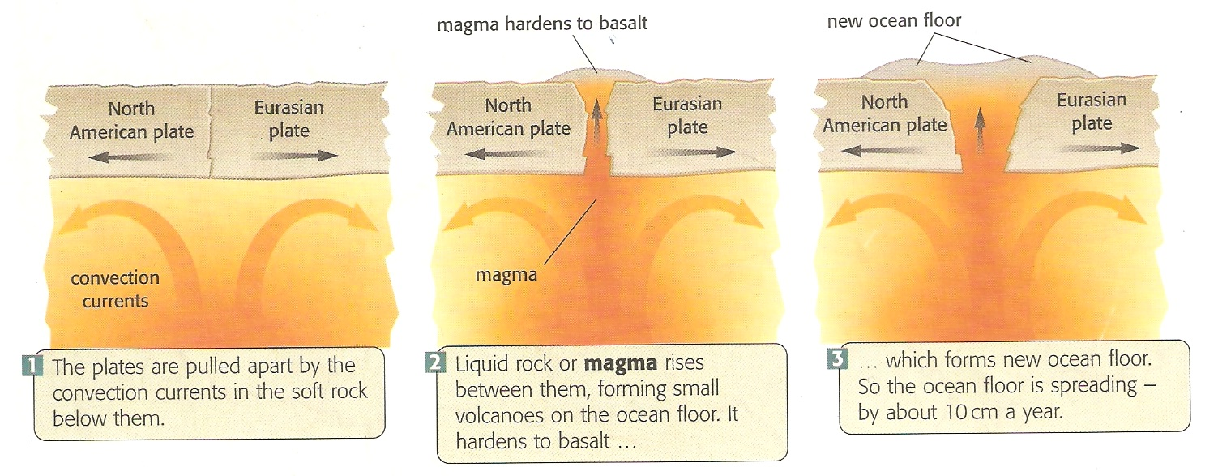

**Destructive Plate Boundary**

At destructive plate boundaries an oceanic plate is forced under a continental plate because the oceanic plate is heavier. This is happening between the Nazca plate and the South American plate. Where the oceanic plate is forced under the continental plate a dip called an ocean trench is formed. The friction of the oceanic going under the continental plate melts the plate creating magma. The friction also results in a lot of pressure causing earthquakes. Volcanoes are often found on the continental plate at a destructive boundary.

