1. What was this trade route known as?

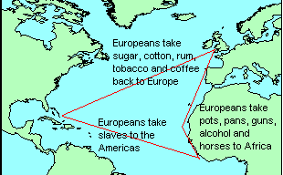

2. What was this leg of the journey called?

3. Choose words from this list that describe how the slaves were treated on the ship?
Chained/ happy/ clean/ sick/ packed/ comfortable/ whipped/ well-fed/ angry/

4. How were slaves sold?

5. 80% of slaves were set to work on plantations. What were the main crops grown on plantations?

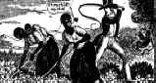
6. Slaves who did not work hard enough were punished.
What forms of punishment were used?

7. For what other reasons could slaves be punished? Choose from the list below.
Talking too much/ cooking on a Sunday/ stealing from a white man/ running away/ eating vegetables/ speaking African/ getting sunburnt/

8. What forms of punishment were used?
© www.historyonthenet.co.uk 2002

