Planning a holiday in Britain
You must create a holiday plan for a family who wish to visit 3 different places in Great Britain! They want to know where to stay, how to get around, and what to do there, and need your advice.
Tick
A map of Great Britain with your chosen places correctly labelled
A picture of each place
Some information about each place; what is the history like? What can they do there? Are there any famous attractions?
A description of how to get there from Carlisle – will they use trains, planes, buses or drive?
For each place, explain why you have chosen that place for the family. Why will they enjoy it?
Any extra information you can think of, eg. The weather, nearby mountains, rivers, etc.

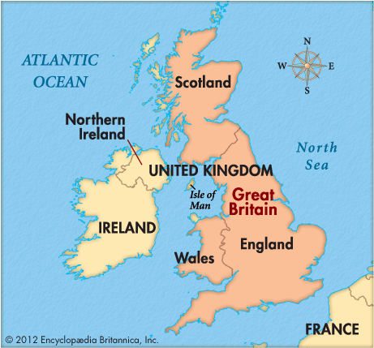
This project will take several lessons so is expected to be done in detail and carefully. You could create a brochure or a leaflet. You may wish to use the computer, but you don’t have to.

You might want to think about places you have been to, or choose some places you have not visited. Remember, you must not copy and paste.

