GCSE Music

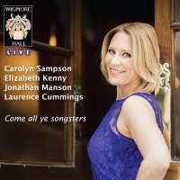

SET WORK BOOKLET

Henry Purcell (1659-1695)

Music For A While

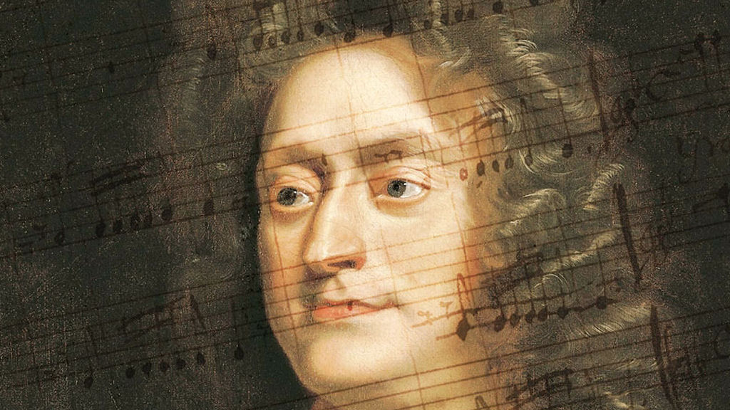

Student Name………………………………………

You will need to use this booklet in conjunction with your course book, where you will find the score of each set work.

Basic Information

Vocal Music

Vocal music is one of the earliest types of music and singing is part of every musical culture. Vocal music of all kinds was important in the Renaissance period and this was when opera was created as an art form. The Baroque period saw the rise of large-scale vocal works, such as cantatas and oratorios, and composers continued to develop forms such as the solo song and operas.

Henry Purcell

Henry Purcell was the most important English composer of his day. He started composing at a young age and was both a composer and an organist. Although he died young, he wrote a great deal of music in all genres. He was an important court composer in the first part of the English Restoration period (1660-c.1720).

- He became organist at Westminster Abbey in 1679.
- He combined that job with being organist at the Chapel Royal from 1682.
- He helped restore the tradition of opera in England, together with John Blow, another English Composer.
- He proved to be skilled in composing in different genres, including opera, church music, chamber music, keyboard and theatre music.
- His best known compositions include ‘Dido and Aeneas’ (1689), ‘King Arthur’ (1691) and ‘The Fairy Queen’ (1692). The last work is an adaptation of Shakespeare’s ‘A Midsummer Night’s Dream’

Purcell wrote during the Baroque period of music, which lasted from c.1600-1750.

Key features of the Baroque Period

- Terraced dynamics (two stages – loud and soft)
- Baroque orchestra – mainly strings with SOME woodwind and brass (depending on the availability)
- Use of Harpsichord (Basso continuo)
- Use of sequences, pedals and suspensions
- Use of ornaments

Other important Baroque composers

 | Year of birth | Year of death | Nationality
Handel
Vivaldi
Corelli
Corelli
John Blow

Consolidation activity

Here is a selection of tasks that get progressively more challenging. You should spend about an hour completing this.

- What are the dates and nationalities of the 5 composers named on the previous page (write these next to their names)?

- Write definitions (that YOU understand) of all the key terms which have been underlined on the previous page. You should do this in the box below.

- This song is from the incidental music to John Dryden’s play Oedipus. Look up the definition of incidental music and write it in the box below.

- Purcell wrote a number of songs for the countertenor voice. What is a countertenor?
________________________________________________________________________________________________________________________________________________________________________________________________
- Listen to another song by Purcell and complete the statement below.
I listened to_________________________________ and I thought that things which were similar were:
a) _________________________________________________________
b) _________________________________________________________
c) _________________________________________________________
And things which were different were;
a) _________________________________________________________
b) _________________________________________________________
c) _________________________________________________________
Keywords and their definitions

Baroque period _________________________________________________________
Harpsichord ___________________________________________________________
Basso Continuo ________________________________________________________
Sequence ____________________________________________________________
Pedal note ____________________________________________________________
Suspension ___________________________________________________________
Ornament ____________________________________________________________
Incidental music _______________________________________________________

Wider Listening (General)

Each piece you listen to requires you to also know about other SIMILAR types of music. They could be similar because
- the same composer wrote them
- because they are written in the same musical period,
- many other reasons.
Here is a list of pieces of music which could be linked to this set work and the composer. The Youtube links are also provided (should you wish to access this booklet online or do the listening on your computer). In the boxes provided, make some notes about why you think each piece is included in the wider listening for this set work.

Piece 1: The Trumpet Shall Sound from Messiah by Handel
Youtube link: https://youtu.be/CYTQ6gpcuYA?list=RDCYTQ6gpcuYA
Comments:

Piece 2: Weichet nur betrübte Schatten by Bach
Youtube link: https://youtu.be/T-oqo1y1uBA
Comments:

Piece 3: Dido’s Lament from Dido and Aeneas by Purcell
Youtube link: https://youtu.be/uGQq3HcOB0Y?list=RDuGQq3HcOB0Y
Comments:

Analysis of Music For A While

Facts about the context and background of the piece
What style is it? What are the key features of this style? Are they in this piece? Is it part of a bigger piece? If so, where does this piece ‘sit’ in comparison?

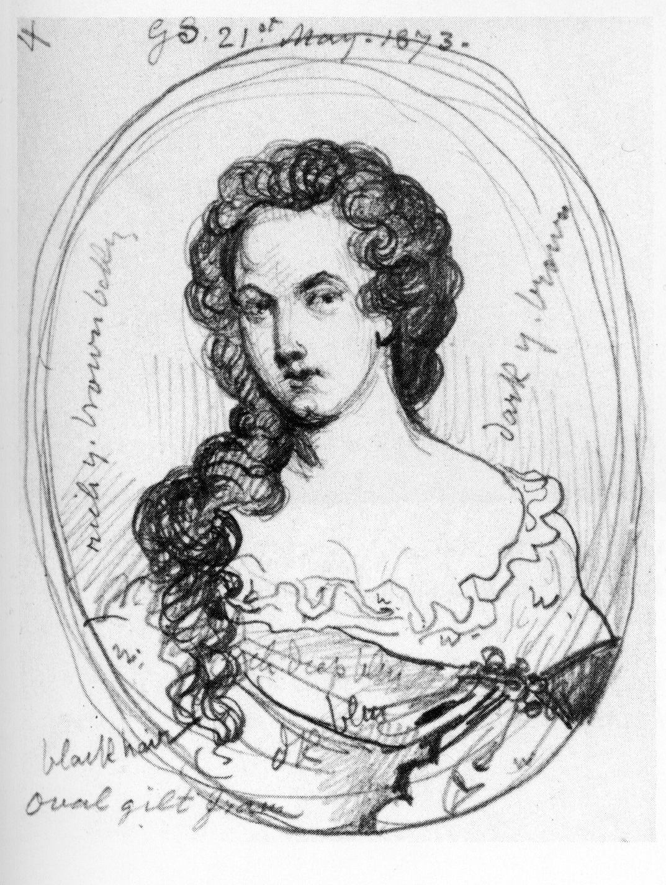 Performing forces and their handling 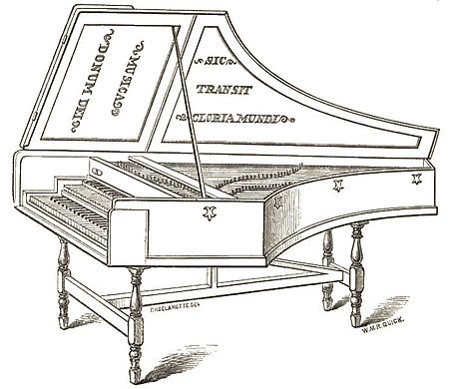
Think about: what instruments are playing in the piece? What role does each of them have? (don’t forget singers!). Is it tricky to play? Why? Does it use a large range for that instrument? Are there any specific techniques used (like mutes, effects etc)? What are the dynamics like in the piece?

Text Setting and word-painting
How are the words set to the music? Where are the important words and how are they highlighted? Is there any repeated text? Are there examples of ‘word-painting’ (where the music depicts exactly what the words say)?

Structure
Think about is it varied? Repeated? Contrasted? Ternary? Sonata Form? Another structure?

Texture
Think about: Monophonic? Polyphonic? Homophonic? Antiphonal? Heterophonic? Pedal? Countermelody? Exchanging ideas in parts? (DIALOGUE).

Melody
Think about: instruments? Doubled melody? Octaves? 3rds? Unison? Regular phrases? Tessitura? Conjunct? Disjunct? Diatonic? Chromatic? Rising? Falling?

Tonality
Think about: Major? Minor? Modal? Atonal? Does the key change?

Harmony
Think about: Use of chords? Chord progressions? Circle of 5ths? 12-bar blues? Important patterns at cadences? Diatonic or chromatic? Functional (I and V and cadences)? Harmonic rhythm? Does it stay the same?

Tempo, rhythm and metre
Think about: Dotted notes? Triplets? Swung quavers? Syncopation? Hemiola? Anacrusis? Time signature (and changes to it)? Strong beats of the bar? Repeated patterns? Key rhythms in the piece? What is the speed of the piece? Does it change? Can you use an Italian term to describe the tempo?

Dynamics
Think about: How would you describe the volume of the piece? Does it change? Are all the instruments the same volume?

Listening activities related to your set work

LISTENING 1 (0.00-0.56secs)
You will hear the piece 3 times.

- Name the first instruments which plays. ________________________________(1 mark)

- Describe the role of the bass viol at the start of the extract.
____________________________________________________________________________________________________________________________________________ (2 marks)

- What is the effect of the repeated word ‘music’ at the start of the vocal line?
____________________________________________________________________________________________________________________________________________

(1 mark)

- Describe the texture during the extract
__________________________________________________________________________________________________________________________________________________________________________________________________________________
(3 marks)

Total /7 marks

LISTENING 2 (0.57-2.07)
You will hear the piece 3 times

- Name the harmonic device heard at the word ‘eased’. ___________________________
(1 mark)
- How is the setting of the word ‘eternal’ an example of word painting? ______________________________________________________________________
(1 mark)
- Which statements best describe relationship of the vocal line and the accompaniment in this extract? (Underline two statements)

- There is imitation between the melody and the accompaniment lines
- There is a trill in the vocal line
- The ground bass phrases are not the same length as the vocal phrases
- The word-setting in this extract is entirely syllabic
(2 marks)

- Name two typical features of Baroque laments which are heard in this extract.
  - _______________________________________________________
  - _______________________________________________________
(2 marks)

Total /6 marks

REINFORCING YOUR LEARNING; In addition to these listening questions you should also be listening to this set work at times when we aren’t studying this piece. You should also be able to identify when particular sections change and also the keys and instruments.
Extended Response question

For each set work, you MIGHT be asked to write in more detail about the piece. You will hear the piece played to you and you will also have a piece of music you’ve NOT studied as well. They will be linked in some way (for example, if you are asked to write about a vocal piece, then the unknown piece is quite likely to be a vocal piece too).

Handel Rejoice Greatly from The Messiah (0.00-2.32)
https://youtu.be/rySvIDZ38Uk

Rejoice Greatly, O Daughter Of Zion

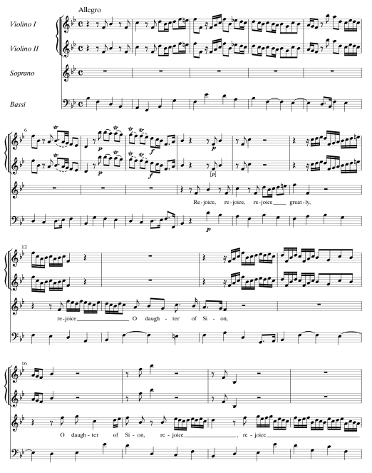

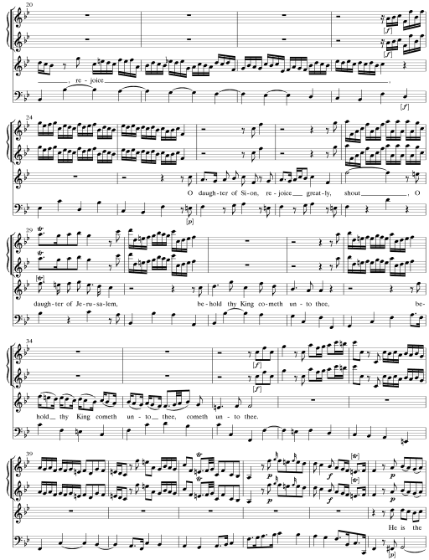

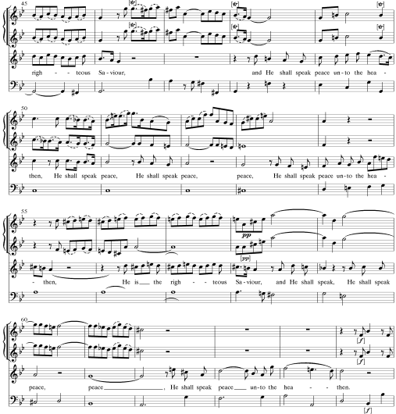

NOTES ON ‘UNFAMILIAR’ PIECE OF MUSIC

Typical Question

Using the notes you have made above and the notes earlier in this booklet about your set work, then answer the following question. You should spend no more than 25 minutes putting the answer together.

Things to consider
- You need to give facts EQUALLY about both pieces.
- It will be marked out of 12 (see the page 17 for the marking guidance from the exam board).
- You should back up each point with a bar reference (or example) from the score. You will need to use the score from your course book for the Purcell.
- Include a conclusion at the end.

QUESTION
Compare and contrast the way in which the texts are set to music in Purcell’s Music for a While and Handel’s Rejoice Greatly. You should ensure that you reference any valid points made.
(12 marks)

Teacher comments and mark

/12
WRITING FRAME HELP
Essay Question:
Compare and contrast the way in which the texts are set to music in Purcell’s Music for a While and Handel’s Rejoice Greatly. You should ensure that you reference any valid points made. (12 marks)
Which musical elements in your notes is this question asking you to discuss?

Paragraph 1 – short introduction.
When were these pieces composed? Are they from the same period? Are they the same kind of piece? Write one sentence about how you are going to set out your answer.

Paragraph 2 – how the text is set to music in Music for a While.
What is the genre of the piece? Identify the performing forces and explain the terms you use. Describe the accompaniment style. Is the word-setting mostly syllabic or melismatic? Give examples of both, if they exist. What is the range of the vocal part? Are some words given special treatment or significance? If so, how is that done and what is the effect? Are there examples of word-painting? Are there some parts that are more virtuosic than others? Does it vary? Write in complete sentences and give examples for each point you make.

Paragraph 3 – how the text is set to music in Handel’s Rejoice Greatly.
What is the genre of the piece? How is it different from the Purcell? Identify the performing forces and explain the terms you use. Describe the accompaniment style. Is the word-setting mostly syllabic or melismatic? Give examples of both, if they exist. What is the range of the vocal part? Are some words given special treatment or significance? If so, how is that done and what is the effect? Are there examples of word-painting? Are there some parts that are more virtuosic than others? Does it vary? Write in complete sentences and give examples for each point you make.

Paragraph 4 – short conclusion.
What are your conclusions? Did you find more differences or more similarities? Did you find one more interesting than the other? If so, why? In your judgement, do the differences and/or similarities suggest that they are typical of their genre/period/style or not?

Teacher comments and mark:

Mark Scheme for 12 mark responses

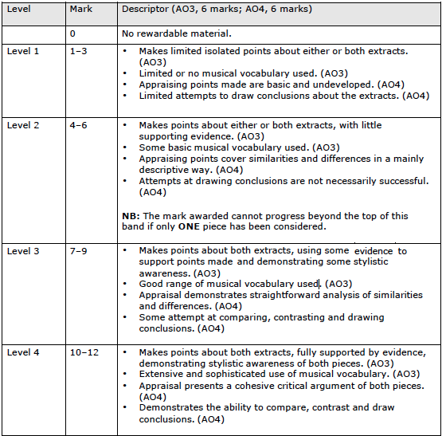

Challenge and consolidation activities

Here is a selection of different activities you could try in relation to this set work. Some are designed to help you check your understanding and others (marked with an *) are designed to challenge you.
Sometimes, these will be set as personalised homework, but other times, they should be used by you outside of your classroom learning to support your knowledge.

- Can you write 2 sentences which describe the structure of this piece?
- Can you create a quiz for other students which includes at least 15 keywords related to this piece?

- What key is this piece in? How do you know?
- Can you list 4 facts about the composer of this piece?
- How many times is the ground bass repeated in this song?
- Can you name 3 other composers who wrote incidental music?
- *Identify three features of Baroque music which are found in this set work.
- *Try to play part of this piece. If you are a keyboard player, have a go at the accompaniment part; if you play a melody instrument or are a singer, try the vocal line.

- *Identify two ways in which Purcell gives particular emphasis to certain words.

- Find three examples of ornamentation used in the piece. How do they contribute to the expressiveness of the music?

- *What are the main chords and cadences used in this set work?

Cross off each of the questions when you have completed them. Lined paper is provided at the end of this booklet for these tasks.

