INVENTION AND INNOVATION Name: __________________
Watch the DVD on James Dyson and answer the following questions:
- What are some of the qualities needed to be successful entrepreneur?

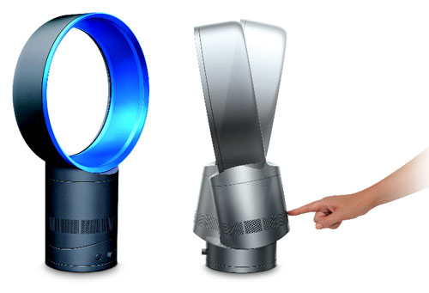
- What is meant by a prototype?

- Why did James Dyson develop prototypes?

- What is meant by a patent?

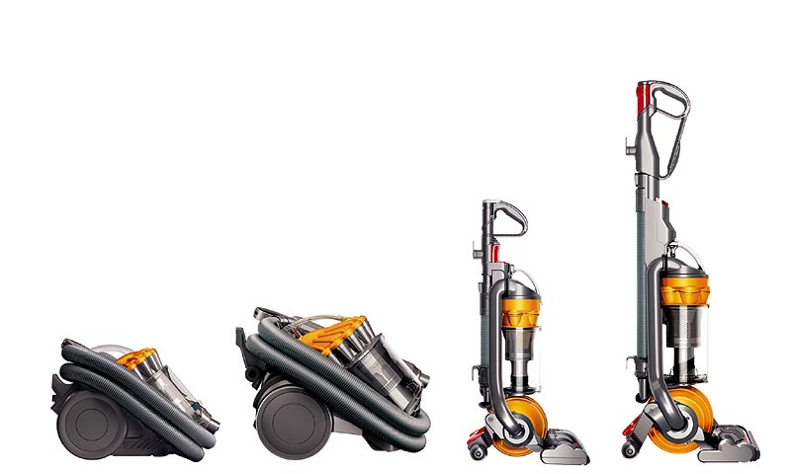
- How long does a patent last for?

- What is the confidential notebook used for?

- Where did James get a manufacturer for his invention?

- How were customer needs different?

- What is a major consideration in the design of new technology? Why?

- What did Dyson need to consider in relation to the environment?

- In your own words, explain the difference between invention and innovation? Objective 2:

