Making plants and animals – The UK
TASK:
You have to create a plant or an animal using the characteristics on the cards. Both of these need to fit the new climate and environment of the UK.
- Your plant or animal can have 6 characteristics
- List the characteristics that would be useful
- Pick six from the lists below
- Draw or create a model of your animal or plant.
- Name your plant or animal
- Around your drawing/model you need to JUSTIFY the characteristics, linking to the original data sheet.

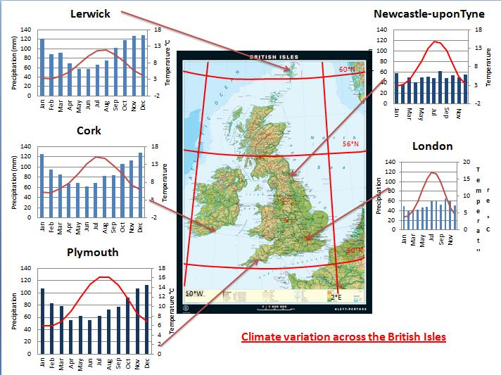
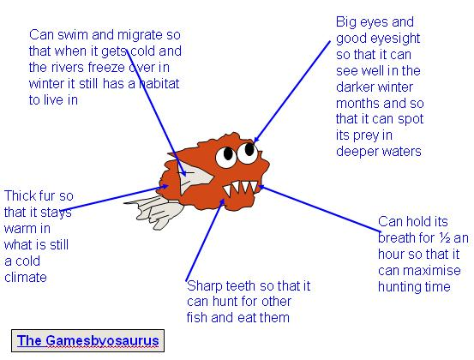
EXAMPLE of an animal
PLANT CHARACTERISTICS

Drought resistant | Loves water | Stores water
Wide root system | Deep root system | Lives on other plants
Floats | Survives under water | Dies back seasonally
Waxy, pointed leaves | Deciduous | Evergreen
Broadleaves | Needle leaves | Stunted
Thick bark | Rough bark | Wind blown seeds
Heavy-weighted seeds | Fragments take root | Seeds with Velcro like hooks
Runners put down roots | Climber | Like strong sun
Likes shade | Tall | Salt tolerant
Bears fruit (nuts and berries) | Flowering | Pollinating
Eats insects | Branching | Sticks to rocks
Lifecycle within days | Colourful | Drab
Pleasant smell | Awful smell | Changes colour
Buttress roots (large roots to support huge trees) | Flexible branches | Sticky surfaces
MAKE UP YOUR OWN CHARACTERISTICS AS WELL!

ANIMAL CHARACTERISTICS

fast runner | Can get fat | Powerful digging claws
Migratory | Thick skin | Spotted fur
Can stand on 2 legs | Large ears | Long neck
Striped fur | Sharp claws | Grinding teeth
Sharp incisor teeth | Swims | Thick fur
Climbs trees | Thick pads on paws | Nocturnal
Good eyesight | Webbed feet | Can hibernate
Can close nostrils | Agile | Slippery skinned
Good sense of smell | Gives off bad smell | Stores water in body
Strong skeleton | Loud voice | Gregarious (lives in groups)
Stamina | Brown fur | Prehensile (gripping) tail
Large body | Very thin body | Whiskers
Can hold breath for 1/2 an hour | sociable | Fierce growl
MAKE UP YOUR OWN CHARACTERISTICS AS WELL!

