Creating Ecosystem Cartoons

Your task is to create a symbolic cartoon or a comic strip depicting the threat to an ecosystem of your choice. An example of what to do is below;

The man is smiling, a symbol of man’s failings?

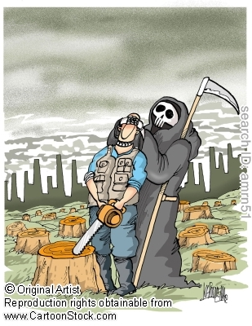
The man is being led blindly to destroy the forest
The sky is grey, symbolic of a dark and bad act
In the background there are the signs of civilisation, buildings and factories, but what civilised people destroys its natural environment?
The lumberjack is guided by the Grim Reaper, alternatively known as DEATH!
No trees are left – total destruction

