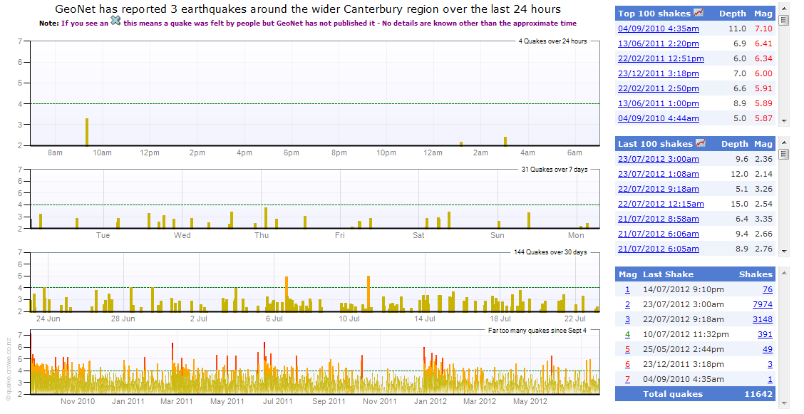
Graphs showing the number of earthquakes in Christchurch, New Zealand since September 2010

