Tectonic Plates in New Zealand

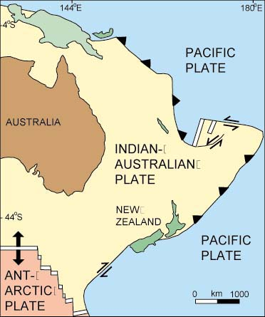
The red dot shows the location of Christchurch.

