EDEXCEL BUILDING A BUSINESS REVISION RESOURCE Name: ___________________________________
MARKETING AND MARKET RESEARCH
What is marketing and why is it important?

What is market research?

Why do market research?

Complete the table below:
 | definition | advantage | disadvantage | Examples
Primary research
Secondary research

In the box below, explain in your own words the difference between primary and secondary research

Explain the difference between quantitative and qualitative data.

PRODUCT TRIAL AND REPEAT PURCHASE
Define the following terms and give examples:
Term | Definition | Examples
Product trial
Penetration pricing
Repeat purchase
Customer loyalty

How can firms encourage product trial?

Why are repeat purchases important to a business?

How can firms encourage repeat purchases?

How can firms build customer loyalty?

PRODUCT LIFE CYCLE
Draw and fully label the product life cycle and then explain what it is in the box provided.

Do all products have the same product life cycle?

What is cash flow?

What is net cash flow?

Explain the link between the product life cycle and cash flow.

Explain what is meant by an extension strategy and give examples?

THE BOSTON MATRIX / PRODUCT PORTFOLIO
What is the Boston Matrix and how is it used?

Define the following terms
Term | Definition | Possible examples
Product portfolio
Product range
Market size
Market growth

Market share

Draw the diagram of the Boston Matrix below and fully label it:

List the types of products in the Boston Matrix

Why is the Boston Matrix useful?

BRANDING
Complete the table below:
Term | Definition | Possible examples
Branding
Product differentiation
Trial purchase

Why is branding important to a business?

How can branding help with repeat purchasing and product trial?

List ways a business can create product differentiation.

BUILDING A SUCCESSFUL MARKETING MIX
What is the marketing mix?
List the key elements of the marketing mix below:
1.
2.
3.
4.

Draw up a marketing mix for the following products – ensure you state the target market the product is being aimed at.
Marketing mix for a Bar of chocolate
Target market: _______________________________

Marketing mix for a Hotel
Target market: _______________________________

MARKETING MIX : PRICE
List factors a business will take into account when setting its price?

Define the following terms:
Term | Definition
Cost-plus pricing
Loss leaders
Mark up
Penetration pricing

Skimming

Term | Definition | Advantage | Disadvantage
Advertising
Sales promotions
Personal selling
Direct marketing

Complete the following table on promotion methods:

What is the difference between a tactic and strategy?

Give example of a tactical marketing decision and a strategic marketing decision.

MEETING CUSTOMER NEEDS
What is design?

Why is design important?

Complete the following table on the design mix:
Design mix | Explanation
Function
Appearance
Cost

What is the role of scientific research in design?
What does R&D stand for?
Explain what R&D means.

What are the drawbacks of R&D?

MANAGING STOCK
Complete the following table:
Term | Explanation
Inventions
Lead time
Buffer stock
Just-in-time
Just-in-case
Why does a firm hold stock?
How does a firm decide on stock levels?
What happens if firms are out of stock?
What are the drawbacks of holding stock?
What is stock control?

Answer the following questions:

List the types of items typically held as stock

What are the two main stock control systems a business uses?
Complete the following stock control diagram
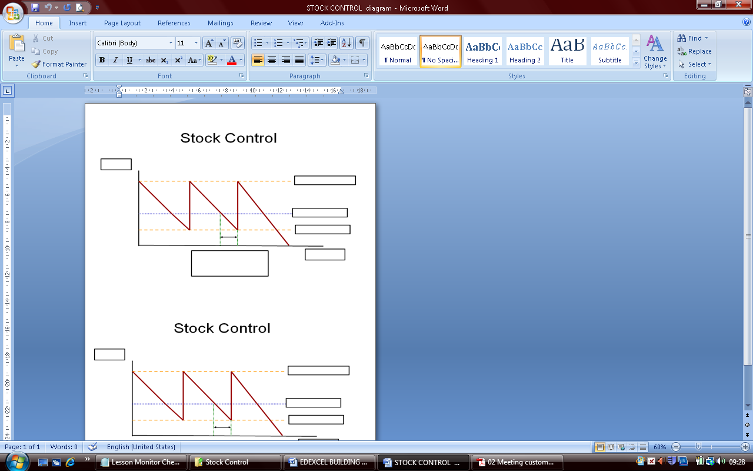

Explain in your own words the stock control diagram and how the buffer stock works.

JIT is the alternative to holding buffer stock, explain the benefits and drawbacks of JIT stock control below:

Just-in-time stock control
Advantages | Disadvantages

MANAGING QUALITY
What is meant by quality?

Does high quality mean a high price?
Quality control
Quality assurance
Kaizen
TQM
Culture
Zero defects
Define the following terms:

Explain the difference between quality control and quality assurance.

OPERATIONS AND COMPETITIVENESS
Define competitiveness.

What is productivity?

What is the formula for productivity?

Calculate the productivity for the following:
 | staff | Output (cars | Productivity
Dacia | 27,000 | 110,000
Nissan | 2,750 | 270,000

Why is productivity important to a business?

List ways a business can improve its productivity.

What is meant by unit costs?

What impact would an increase in productivity have on a business’s competitiveness?

CUSTOMER SERVICE
What is customer service?

What is effective customer service?

Why is customer service important to a business?

How can businesses improve their customer service?

List the likely consequences of poor customer service

CONSUMER PROTECTION LAWS
What is mean by the law?
Outline the main features of the following laws:
Sales of Goods Act
Trade Descriptions Act
What are the effects of consumer protection laws on business?

EFFECTIVE FINANCIAL MANAGEMENT
How to improve cash flow
Define the following terms, give examples or formulas where necessary:
term | Definition /formula
Cash flow
Cash inflow
Cash outflow
Net cashflow
Cash surplus
Cash shortage
Cash flow forecast
Financial management

How can firms improve cash flow?
1.
2.
How can firms increase cash receipts?

Complete the following table:
term | Definition | Advantage | Disadvantage
Trade credit
Destocking
Overdraft
Bank loan
Debtors
Sale of assets
Sale and lease back

How can extra finance improve cash flow?

How can firms reduce cash payments?

IMPROVING PROFITABILITY

What is profit?

What is the formula for profit?

What is meant by profit margin?

How can firms raise profit?

How can costs be cut?

BREAKEVEN ANALYSIS
Define the following terms:
Term | definition | Example
Breakeven
Revenue
Fixed costs
Variable costs
Total costs
Breakeven graph
Output
Margin of safety
Contribution

Explain the advantages and disadvantages of breakeven analysis
Advantages | Disadvantages

Draw an example of a breakeven graph in the box below and fully label it. Show the margin of safety. Explain in detail what the breakeven chart shows and how it can be interpreted.
Breakeven graph
Interpretation

What happens to the cost line if costs change?

What happens to the total revenue line if price changes?

What is the formula for contribution?

What happens to contribution?

How is contribution used to estimate the breakeven level of output?

FINANCING GROWTH
How can a business grow?

Define the following terms, give examples where possible.
term | Definition | examples
Finance
Sources of finance
Short term sources of finance
Internal finance
External finance
Assets
Retained profit
Share capital
Company
Shareholder
Shares
Stock market
Stock market flotation
Private limited company
Public limited company

How do firms decide on the best source of finance?

EFFECTIVE PEOPLE MANAGEMENT

ORGANISATION STRUCTURES
Explain the following terms:
Organisation structure

Division

Subsidiary

Roles and responsibilities

Organisation chart

Delegation

Authority

Use the graph below to explain span of control, levels of hierarchy, line manager

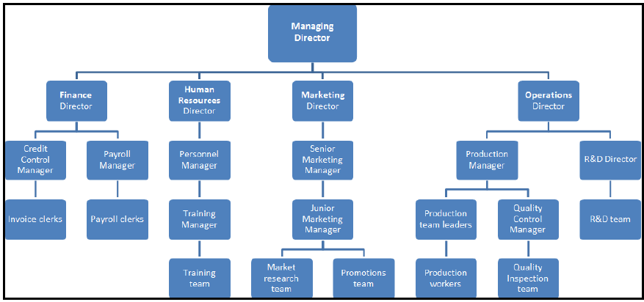

MOTIVATION
Why is it important to have a mo vitiated workforce?

Draw Maslow’s Hierarchy of Needs below and state how each part could be applied to a business.

