WHAT TYPE OF BUSINESS ORGANISATION?
LIMITED OR UNLIMITED LIABILITY

- Limited liability - protected to the amount invested
If a business has the letters LTD or PLC after its name, it means that its owners have LIMITED LIABILITY and it is a company. This means that if the business goes into debt and cannot pay its debts, its creditors can only take money from the business assets. In other words all the owner(s) personal assets are safe and cannot be touched by creditors to pay off the debts of a business. When a business has limited liability it means that in the eyes of the law the business is a legal person separate from its owners and therefore the business can sue and be sued. All limited companies have limited liability.

- Unlimited liability - greater risk stand to loose personal assets
Other businesses such as sole traders and partnerships have unlimited liability and this means that if the business goes into debt and cannot pay its debts then creditors can take their money from the owners business and personal assets. In other words everything of value owned by the owners of the business may be sold to pay the debts of the business. When a business has unlimited liability it means that in the eyes of the law the business and the owner(s) are the same person they are not separate. All sole traders and partnerships have unlimited liability.

CASE STUDY 1 - The sad story of builder Fred Jones!
Fred Jones set up as a self-employed builder and decorator 3 years ago. Things went well for Fred at first and he started taking on other workers to help him. Unfortunately, whilst working on a property, one of Fred’s workers punctured a water main and caused several thousand pounds damage. Fred hired most of his equipment and he did not have the necessary cash in the business to pay for the damage. The result was that Fred had to sell his most prized possession, his vintage sports car, in order to raise the cash. Fred’s personal property was at risk; in this case his car.

CASE STUDY 2 - The collapse of Jo Jeans Ltd

In July 2003, a small firm making high-fashion jeans, went bankrupt due to competition from foreign firms who could make and sell the jeans at a much lower cost. At the time of going bankrupt Jo Jeans Ltd owed £2000 to their suppliers and had a loan from the bank of £5000.

A ‘receiver’ (official person who distributes the assets of the business to those people who are owed money) was called in to arrange for the debts to be settled by selling off all the property belonging to Jo Jeans (known as the assets of the business). This included their stock, machinery, van etc. All this amounted to only £6000. The bank had first claim on this money and the suppliers were left being owed £1000. Only the value of Jo Jeans business was at risk.

LIMITED AND UNLIMITED LIABILITY
Fred Jones and Jo Jeans Ltd

- Which business has limited liability?

- Which business has unlimited liability?

- Who lost out through Limited Liability? 1 mark

- Who lost out through Unlimited Liability? 1 mark

- What assets could Fred Jones have to sell to pay the business debts?

- What is the correct business term given to the people who owe money to Fred and Jo Jeans Ltd? 1

- Explain what is meant by unlimited liability. 2

- Explain what is meant by limited liability. 2

- A sole trader faces more risk than a shareholder in a company because of
A changes in profits
B lack of control of the business
C unlimited liability
D lack of privacy
Select one answer.

- What is the main advantage of being a sole trader?
Unlimited liability
Limited liability
Be able to make quick decisions
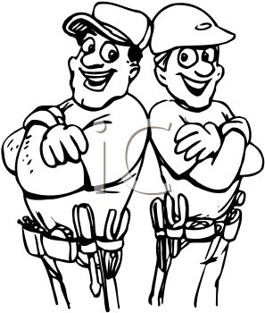
Select one answer

- Who is limited liability an advantage to?
Shareholders
Stakeholders
Sole traders
Select one answer

