In the 1940s the American’s were in a technological race with the USSR to build the best nuclear weapon. The US Navy went to a group of 23 islands in the Pacific Ocean to conduct tests of these weapons. Many of the iconic pictures of mushroom clouds are from tests in these islands.

Before the USA started the nuclear tests it was a peaceful group of islands (an atoll) with a small local population (the Micronesians) of 200 people, who survived mainly by fishing. The islands were part of the USA after WW2 but are now independent and part of the Marshall Islands. The local people were moved to the nearby Rongerik Atoll and Kili Island during the tests.

The bikini swimsuit is named after the island.

Between 1946 and 1958, 23 nuclear bombs were detonated at Bikni atoll. This led three islands being completely destroyed and others contaminated with radiation. One of the explosions, Castle Bravo, was the biggest ever nuclear explosion and spread contamination over a large area, including a Japanese fishing vessel, where 23 people fell ill. Many of the US sailors, scientists and soldiers were also exposed to high levels of radiation. This led to illness and some cancers.

In 1968 the US government said that Bikini atoll was safe to live on again and tried to bring people back to live there. However when people were tested they had high levels of radiation in their bodies and so were evacuated again. The atoll is now considered not safe to live on because of the levels of radiation.

The people who used to live on the islands now live on nearby islands and receive money from the US government as compensation for the loss of their homes. Many of these people have had illnesses due to the radiation and some of their children have been born with abnormalities.

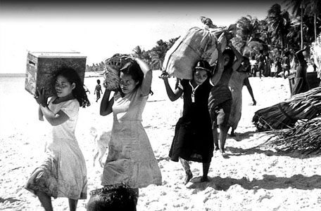
Bikini atoll is now a world heritage site which means it is protected. The original residents want the USA to remove the topsoil on the islands to make it safe to live on again, however this would ruin the environment and turn the islands into desert wastelands.

During the tests the navy sunk many ships around the islands to test what would happen to ships in a nuclear attack. These ships have created artificial reefs which are perfect for scuba diving.

As there are no humans fishing around the islands there is an abundance of sea life including fish and sharks. The food here (including fish) is contaminated though, so boats visiting the islands must bring their own food. The ground on the islands is safe to work on now but you couldn’t live their because of the contaminated food.

As there are no humans, wildlife is abounded on the islands, such as lizards, birds and crabs. There is a well developed coral reef, which has recovered from the damage caused by the explosions. The plant life on the atolls was originally completely wiped out by the explosion but it is now recovering.

