In the early hours of April 26th 1986, a nuclear reactor (something that makes electricity) blew up at the Chernobyl Nuclear Power Plant, near Pripyat, Ukraine. The explosion and fire released large amounts of radioactivity (dangerous particles) into the air.

After the accident the reactor was covered in concrete to contain the radiation and many people from the surrounding towns and villages were evacuated (moved away). There is now a 19 mile area around the nuclear power plant that people are not allowed to live in, although some people do. This is to stop people getting ill because of the radiation.

The accident is considered the worst nuclear accident in history, closely followed by the Fukushima accident in Japan in 2011. Over 500,000 people were involved in the emergency effort and clean up.

The accident contaminated 100,000 km² with radioactivity, the radiation spread all over Europe, even to the UK. In many countries certain foods were banned to stop people getting sick. These bans were lifted after a few weeks.

237 people who worked at the plant got radiation sickness, 31 of these people died within three months of the accident. Many more people have died since due to cancer caused by the radiation, but it is very hard to tell how many of the cancers were caused by the accident. Some children living in the area and nearby have suffered from diseases caused by the radiation since the accident.

135,000 people had to be evacuated from the area around Chernobyl, many of those can never go home again. In Pripyat, the nearest town, 50,000 people were moved. There are still houses and schools with meals on the tables and books on desks because the people had to leave very quickly. Many people left behind everything they owned, and many are still very sad about leaving. Many people are also very scared that they will get ill because of the radiation.

The water around the Chernobyl plant was contaminated with radiation, making it unsafe to drink. Many fish were killed by the radiation in the water. The nearby forest was contaminated by radiation and in the first few months many animals died.

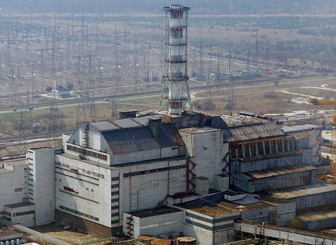
In the exclusion zone the number of animals has increased since the accident. This is probably because humans, the main predator, have been removed. There are moose, roe deer, wild boar, otters and wolves found in the exclusion zone; none of which are found in the countryside immediately outside the exclusion zone.

Tourists can visit Pripyat and Chernobyl by taking special coach tours from the nearest city Kiev. People are stopped at checkpoints and have their radiation levels monitored by Geiger counters to ensure they are not exposed to harmful levels of radiation. People have to wear clothes that cover their whole body and wear closed shoes, to protect themselves from the radiation; they are not allowed to eat in the zone or cannot touch anything in the zone. Soldiers are responsible for monitoring who goes in and out (you need a permit), and if vehicles or equipment are contaminated by radiation they are confiscated. You have to be over 18 and healthy to visit.

The people who build power plants learnt many lessons from Chernobyl about how to make nuclear power stations safer. Governments’ also learnt about what would happen in the event of an accident and now have plans in place to evacuate people safely should an accident happen at another power station.

