*CUP/T50899*

ADVANCED GCE | F248
APPLIED BUSINESS
Unit 9: Strategic Decision-Making
FRIDAY 11 JANUARY 2008 | Afternoon
 | Time: 2 hours

Candidates answer on the question paper

Additional materials (enclosed): Clean copy Case Study

Additional materials (required):

Calculator
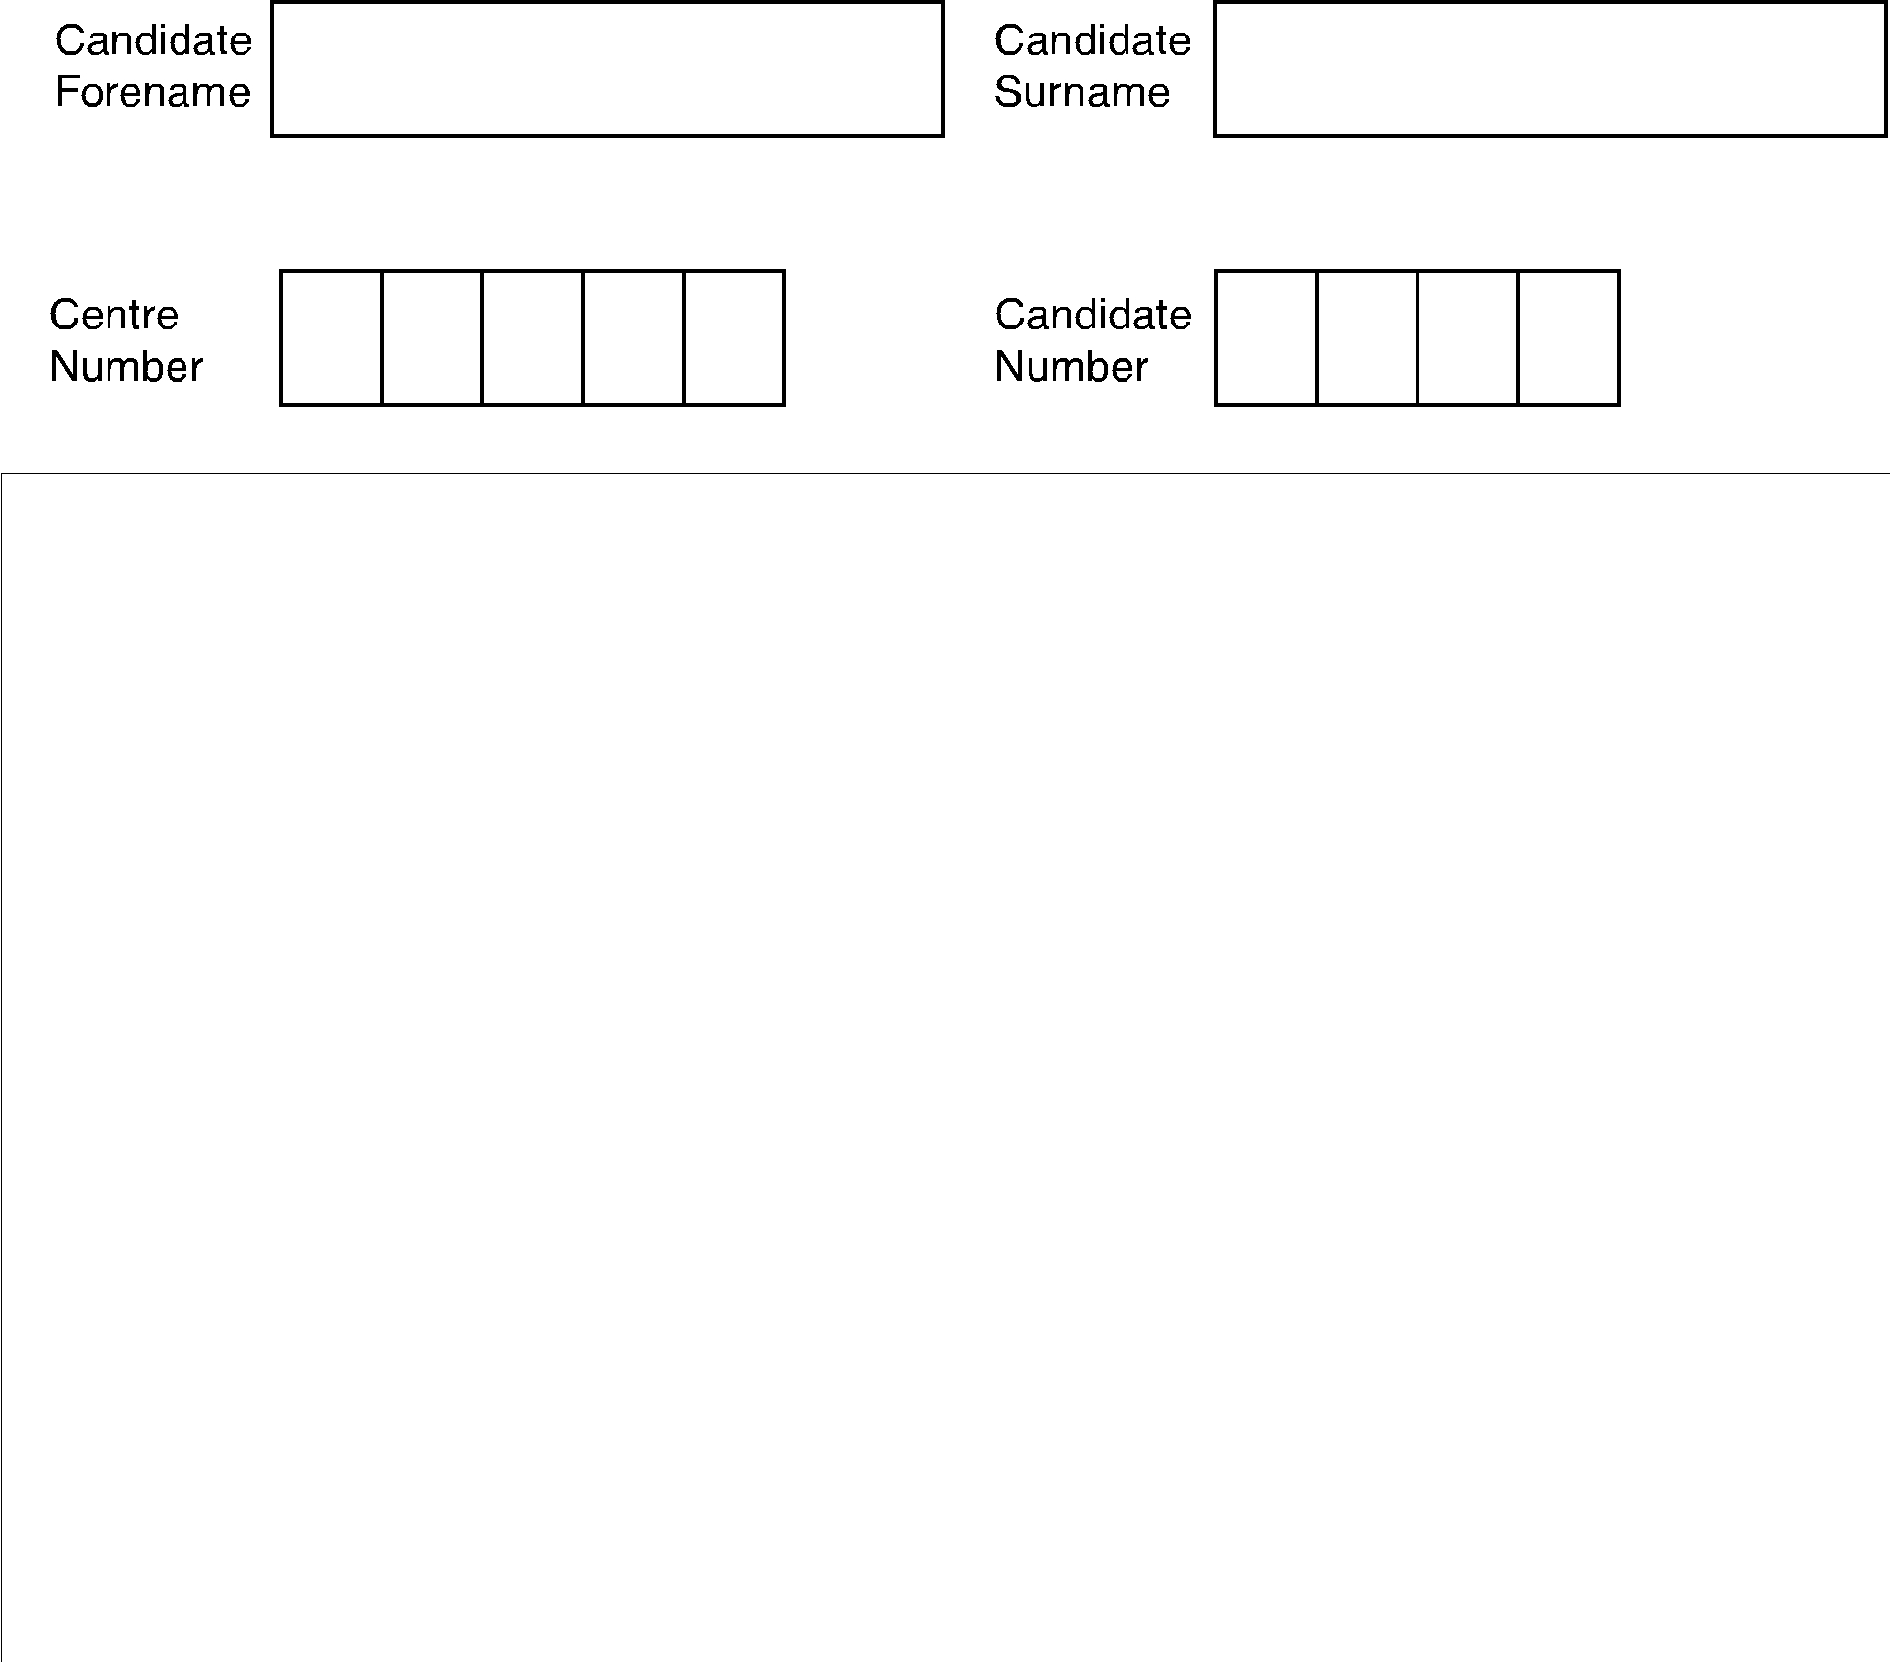

INSTRUCTIONS TO CANDIDATES

• Write your name in capital letters, your Centre Number and Candidate Number in the boxes above.

• Use blue or black ink. Pencil may be used for graphs and diagrams only.

- Read each question carefully and make sure that you know what you have to do before starting your answer.
- Answer all the questions.

- Do not write in the bar codes.

- Do not write outside the box bordering each page.
• | Write your answer to each question in the space provided. |  | FOR EXAMINER’S USE
• | Additional answer space is available on the lined pages at the back of this |  | 1
 | booklet. Answers on these pages must be clearly numbered. |  | 1
INFORMATION FOR CANDIDATES |  |  | 2
 |  |  | 3
• | The number of marks for each question is given in brackets [ | ] at the end | 3
 | of each question or part question. |  | 4
• | The total number of marks for this paper is 100. |  | 4
• | The quality of written communication will be taken into account in marking |  | 5
 | your answer to the question marked with an asterisk (*). |  | 5
 |  |  | 6
 |  |  | 7
 |  |  | TOTAL

This document consists of 12 printed pages, 2 lined pages and 2 blank pages.

SPA (SHW 00049 5/07) T50899/4 © OCR 2008 [F/102/8214] OCR is an exempt Charity [Turn over

2 BLANK PAGE

PLEASE DO NOT WRITE ON THIS PAGE

© OCR 2008

 |  | 3
1 | (a) | Other than Shareholders, identify three stakeholders in CD plc.
 |  | 1. ...............................................................................................................................................
 |  | 2. ...............................................................................................................................................
 |  | 3. ......................................................................................................................................... | [3]
 | (b) | Explain two issues which might have caused conflict between stakeholders before the two
 |  | options arose.
 |  | 1. ...............................................................................................................................................
 |  | ...................................................................................................................................................
 |  | ...................................................................................................................................................
 |  | ...................................................................................................................................................

...................................................................................................................................................

...................................................................................................................................................

2. ...............................................................................................................................................

...................................................................................................................................................

...................................................................................................................................................

...................................................................................................................................................

...................................................................................................................................................

............................................................................................................................................. [6]

[Total: 9]

© OCR 2008

[Turn over

4

- The Directors decided to do a break-even analysis on the new venture in Option One, the building of an industrial estate. They based their calculations on:

  - Average selling price of £150,000 per property;

  - variable costs of £50,000 per house;

  - fixed costs of £2,000,000;

(a) Using the break-even formula, calculate how many houses CD plc would need to be

produced per annum to break-even. | [4]
Show your working:

Answer: ..............................................................................

(b) Shareholders decide to produce and sell 40 standardised industrial units. Calculate:
(i) the margin of safety at this level of output; | [2]
Show your working:

Answer: ..............................................................................

(ii) the profit made at this level of output. [3]

Show your working:

Answer: ..............................................................................

- Describe two limitations of using break-even analysis as a decision-making tool.

1. ...............................................................................................................................................

...................................................................................................................................................

...................................................................................................................................................

...................................................................................................................................................

2. ...............................................................................................................................................

...................................................................................................................................................

...................................................................................................................................................

............................................................................................................................................. [4]
5

- If CD plc decide to go ahead with option 1 and amalgamate with another development company, which source of finance should they use to generate the £4 million the project will cost. Justify your answer.

...................................................................................................................................................

...................................................................................................................................................

...................................................................................................................................................

...................................................................................................................................................

...................................................................................................................................................

...................................................................................................................................................

...................................................................................................................................................

...................................................................................................................................................

...................................................................................................................................................

...................................................................................................................................................

...................................................................................................................................................

...................................................................................................................................................

...................................................................................................................................................

...................................................................................................................................................

...................................................................................................................................................

...................................................................................................................................................

...................................................................................................................................................

...................................................................................................................................................

...................................................................................................................................................

...................................................................................................................................................

...................................................................................................................................................

...................................................................................................................................................

...................................................................................................................................................

........................................................................................................................................... [12]

[Total: 25]

© OCR 2008 [Turn over
6

- (a) Identify TWO strategic objective which a PLC might set:

  - Objective 1;

..................................................................................................................................... [1]

(ii) Objective 2:

..................................................................................................................................... [1]

(b) Analyse how useful Porter’s Generic Strategies could be used to help CD plc in achieving a competitive advantage.

...................................................................................................................................................

...................................................................................................................................................

...................................................................................................................................................

...................................................................................................................................................

...................................................................................................................................................

...................................................................................................................................................

...................................................................................................................................................

...................................................................................................................................................

...................................................................................................................................................

...................................................................................................................................................

...................................................................................................................................................

............................................................................................................................................. [6]

[Total: 8]
7

4 If Shareholders decide to accept Option One they have been advised by Alison that the scale of production will have to change, as will efficiency. They put together a table of the activities for the new 40 industrial plots pots – along with timing and manning levels.

Activity | Task | Time Duration | Manning
 |  | (week) | (workers allocated
 |  |  | to task)
A | Foundations | 70 | 6
B | Building work | 20 | 3
C | Roofing | 125 | 1
D | Electricals | 60 | 1
E | Windows | 50 | 1
F | Doors | 15 | 4
G | Plumbing | 40 | 0
H | Kitchen and bathrooms | 50 | 0
I | Painting | 10 | 2
J | Landscaping | 125 | 7

(a) Using the table above complete the EST (earliest start time) and LFT (latest finish time) for

 |  | each node on the network diagram. Nodes 1, 2, 3 and 5 are already complete. |  |  |  |  |  |  |  |  |  |  |  |  |  | [10]
 |  |  |  |  |  |  |  | 195
 |  |  |  |  |  | 3 |  | 195
 |  |  |  |  |  |  |  | 195
 |  |  |  |  |  |  |  |  |  | H
 |  |  |  |  |  | C |  |  |  | H
 |  |  |  |  |  |  |  | 50
 |  |  |  |  |  | 125
 | 0 | A |  |  | 70 | D |  |  | F |  | G |  | I |  |  | J
1 |  |  |  | 2 |  |  | 4 |  |  | 6 |  | 7 |  | 8 |  |  | 9
1 | 0 | 70 |  | 2 | 70 | 60 | 4 | 15 |  | 6 | 40 | 7 | 10 | 8 |  | 125 | 9
 |  |  |  |  |  | E
 |  |  |  | B |  | 50
 |  |  | 20 |  |  | 5 |  | 120
 |  |  |  |  |  |  |  | 190
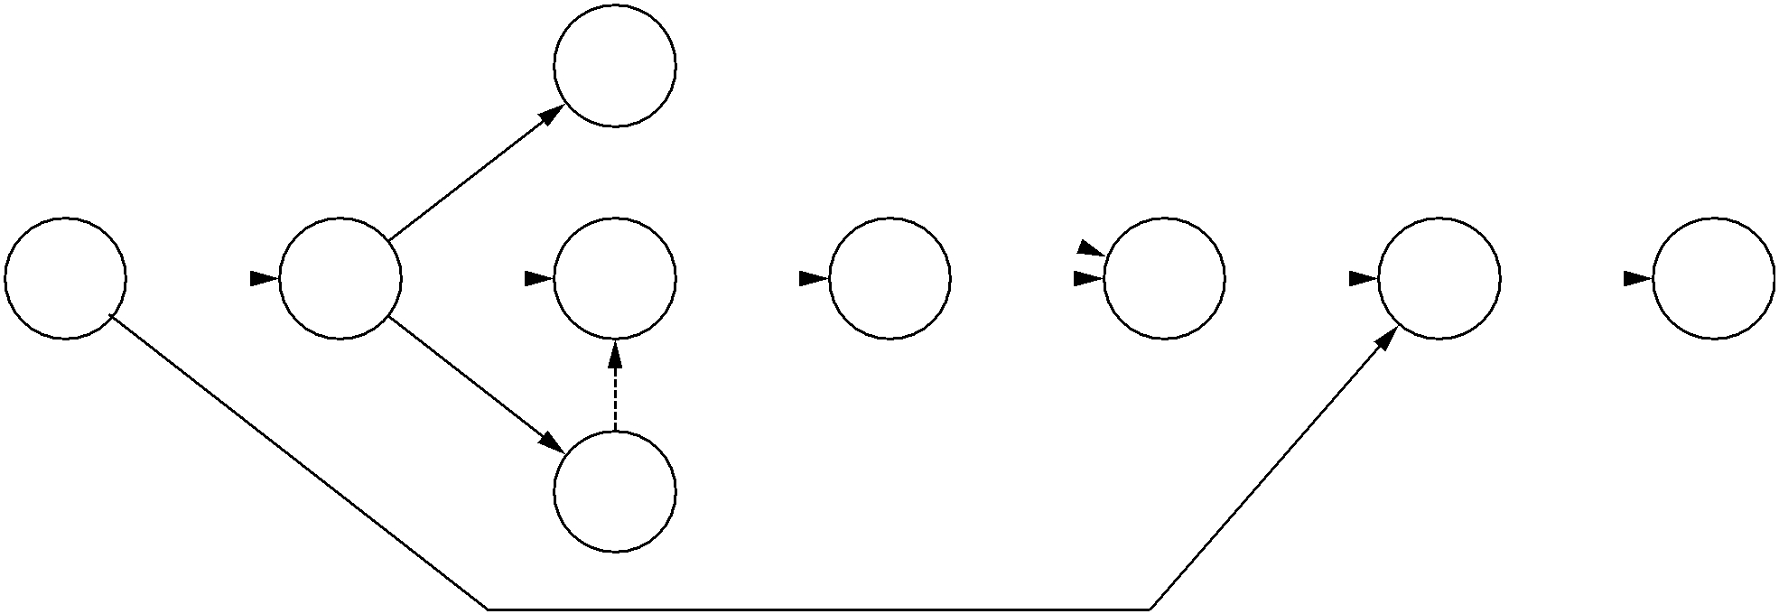

© OCR 2008

9

- Calculate the total float for activities:

  - B; [2]

Show your working:

Answer: ..............................................................................

(ii) | F. | [2]
Show your working:
Answer: ..............................................................................

- Using the information available, explain two ways in which CD plc could use the floats to improve efficiency.

1. ...............................................................................................................................................

...................................................................................................................................................

...................................................................................................................................................

...................................................................................................................................................

...................................................................................................................................................

...................................................................................................................................................

2. ...............................................................................................................................................

...................................................................................................................................................

...................................................................................................................................................

...................................................................................................................................................

...................................................................................................................................................

............................................................................................................................................. [6]

[Total: 20]

© OCR 2008

[Turn over

10

5 Alison uses a discount rate of 10% to judge the likely performance of her investments. Use the discount factors given to complete the net present value table of Option 1 in the table below. [4]

Year | Discount factor
0 | 1.00
1 | 0.91
2 | 0.83
3 | 0.75
4 | 0.68
5 | 0.62

Option 1

Year | Net cash flow | Present value | Working
0 | (4 000 000) | (4 000 000)
1 | 1 800 000
2 | 1 500 000
3 | 2 500 000
 | TOTAL


© OCR 2008

11

- (a) What is meant by the term ‘labour productivity’?

...................................................................................................................................................

...................................................................................................................................................

...................................................................................................................................................

............................................................................................................................................. [2]

- Shareholders have been considering Option two, downsizing, from the point of view of change in relation to human resources.

Discuss the issues which might arise with staffing should they decide to take this option.

...................................................................................................................................................

...................................................................................................................................................

...................................................................................................................................................

...................................................................................................................................................

...................................................................................................................................................

...................................................................................................................................................

...................................................................................................................................................

...................................................................................................................................................

...................................................................................................................................................

...................................................................................................................................................

...................................................................................................................................................

...................................................................................................................................................

...................................................................................................................................................

...................................................................................................................................................

...................................................................................................................................................

...................................................................................................................................................

...................................................................................................................................................

...................................................................................................................................................

...................................................................................................................................................

...................................................................................................................................................

...................................................................................................................................................

...................................................................................................................................................

........................................................................................................................................... [12]

[Total: 14]

© OCR 2008 [Turn over
12

7* Using both quantitative and qualitative information, recommend and justify which of the two options CD plc should select.

..........................................................................................................................................................

..........................................................................................................................................................

..........................................................................................................................................................

..........................................................................................................................................................

..........................................................................................................................................................

..........................................................................................................................................................

..........................................................................................................................................................

..........................................................................................................................................................

..........................................................................................................................................................

..........................................................................................................................................................

..........................................................................................................................................................

..........................................................................................................................................................

..........................................................................................................................................................

..........................................................................................................................................................

..........................................................................................................................................................

..........................................................................................................................................................

..........................................................................................................................................................

..........................................................................................................................................................

..........................................................................................................................................................

..........................................................................................................................................................

..........................................................................................................................................................

..........................................................................................................................................................

..........................................................................................................................................................

..........................................................................................................................................................

..........................................................................................................................................................

..........................................................................................................................................................

© OCR 2008

13

..........................................................................................................................................................

..........................................................................................................................................................

..........................................................................................................................................................

..........................................................................................................................................................

..........................................................................................................................................................

..........................................................................................................................................................

..........................................................................................................................................................

..........................................................................................................................................................

..........................................................................................................................................................

..........................................................................................................................................................

..........................................................................................................................................................

..........................................................................................................................................................

..........................................................................................................................................................

.................................................................................................................................................. [20]

© OCR 2008

14

If you use these lined pages you must write the question number next to your answer.

..................................................................................................................................................................

..................................................................................................................................................................

..................................................................................................................................................................

..................................................................................................................................................................

..................................................................................................................................................................

..................................................................................................................................................................

..................................................................................................................................................................

..................................................................................................................................................................

..................................................................................................................................................................

..................................................................................................................................................................

..................................................................................................................................................................

..................................................................................................................................................................

..................................................................................................................................................................

..................................................................................................................................................................

..................................................................................................................................................................

..................................................................................................................................................................

..................................................................................................................................................................

..................................................................................................................................................................

..................................................................................................................................................................

..................................................................................................................................................................

..................................................................................................................................................................

..................................................................................................................................................................

..................................................................................................................................................................

..................................................................................................................................................................

..................................................................................................................................................................

..................................................................................................................................................................

© OCR 2008

15

..................................................................................................................................................................

..................................................................................................................................................................

..................................................................................................................................................................

..................................................................................................................................................................

..................................................................................................................................................................

..................................................................................................................................................................

..................................................................................................................................................................

..................................................................................................................................................................

..................................................................................................................................................................

..................................................................................................................................................................

..................................................................................................................................................................

..................................................................................................................................................................

..................................................................................................................................................................

..................................................................................................................................................................

..................................................................................................................................................................

..................................................................................................................................................................

..................................................................................................................................................................

..................................................................................................................................................................

..................................................................................................................................................................

..................................................................................................................................................................

..................................................................................................................................................................

..................................................................................................................................................................

..................................................................................................................................................................

..................................................................................................................................................................

..................................................................................................................................................................

..................................................................................................................................................................

..................................................................................................................................................................

