Chapter 12: How to improve cash flow
1. Plante is a business which manufactures lawnmowers. It takes out a loan from a bank repayable over four years. For Plante, this will lead to an immediate large cash...

A inflow and smaller cash outflows over a period of time
B inflow and smaller cash inflows over a period of time
C outflow and smaller cash inflows over a period of time
D outflow and smaller cash outflows over a period of time.
Select one answer.
2. Gaweda is a company which manufactures parts for DVD players. De-stocking by Gaweda of both raw materials and finished products occurs in February. Between February and April, this is most likely to lead to
A improved cash flow because more raw materials will be ordered
B improved cash flow because fewer raw materials will be ordered
C improved cash flow because fewer finished products will be sold
D a deterioration in cash flow because more finished products will be sold.
3. Which one of the following is most likely to lead to improved cash inflows for a business? Select one answer.
A Increasing the amount of materials bought from suppliers
B Increasing the level of stocks of raw materials held by the business
C Reducing the length of time customers are given to pay their invoices
D Reducing the amount of time taken by the business to pay its suppliers

Effects on cash flow. Write the effect on cash flow in the correct box.
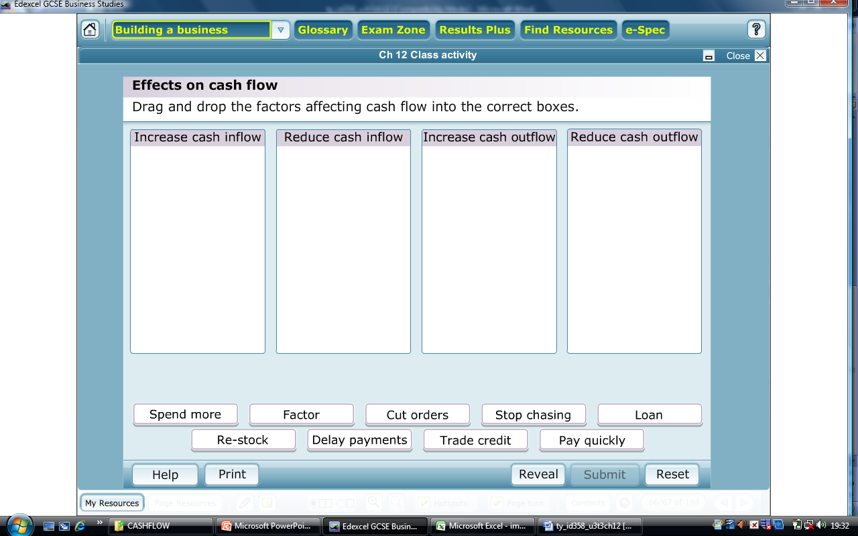
- Spend more on electricity
- Make use of the services of a factor
- Order fewer materials
- Stop chasing outstanding payments over 90 days
- Take out a bank loan
- Re-stock materials at a higher level
- Delay paying invoices
- Extend the trade credit period from 30 to 90 days
- Encourage customers to pay invoices more quickly

