Calculating Costs, Revenues, Profits, Contribution and Breakeven

1(a) What is the formula for calculating profit?

_____________________________________________________________________________________________
(1 mark)

- Footie & Co sells footballs priced at £7.45 each. In a month they sell 234 footballs. Calculate their sales revenue for the month.
____________________________________________________________________________________________________________________________________________________________________________________________________________________________________________________________________________________________________________________________________________________________________________________
(2 marks)

2 Charlotte’s sells soft toys priced at £4.25 each. Their average sales per month in 2010 were 220. Calculate their revenue for 2010.
____________________________________________________________________________________________________________________________________________________________________________________________________________________________________________________________________________________________________________________________________________________________________________________
(3 marks)

3 The revenue of Coffee to Go in 2010 was £545M. Their total costs were £28.5M. Calculate their profit (loss) for 2010.
____________________________________________________________________________________________________________________________________________________________________________________________________________________________________________________________________________________________________________________________________________________________________________________
(2 marks)

4 Sergio Plc made a profit of £25M in 2010. Their revenue was £132M. Calculate their total costs.
____________________________________________________________________________________________________________________________________________________________________________________________________________________________________________________________________________________________________________________________________________________________________________________
(2 marks)

5 In 2010 Ahmed’s Toys had a revenue of £3.2M, fixed costs of £2.75M and variable costs of £530 000. Calculate their profit (loss) for 2010.
____________________________________________________________________________________________________________________________________________________________________________________________________________________________________________________________________________________________________________________________________________________________________________________
(3 marks)

6 Energise has fixed costs of £10 000 per month and variable costs of £0.75 per energy bar made. It sells
1 500 bars per month. What is its total costs per month?
____________________________________________________________________________________________________________________________________________________________________________________________________________________________________________________________________________________________________________________________________________________________________________________
(3 marks)
Extension: What actions can a business take to increase profit?
Total / 16

- (a) What is the formula for calculating contribution?

(1 mark)

(b) Peter’s window cleaning business has an annual sales revenue of £126 550 and total annual variable costs of £77 290. Calculate the total contribution.
____________________________________________________________________________________________________________________________________________________________________________________________________________________________________________________________________________________________________________________________________________________________________________________ (2 marks)
Total / 17

(c) Peter’s window cleaning business makes 9 000 customer visits each year. Calculate the contribution per visit (unit).
____________________________________________________________________________________________________________________________________________________________________________________________________________________________________________________________________________________________________________________________________________________________________________________
(2 marks)

(d) Peter’s window cleaning business has annual fixed costs of £10 560. Calculate the annual profit.
____________________________________________________________________________________________________________________________________________________________________________________________________________________________________________________________________________________________________________________________________________________________________________________
(2 marks)

2 Pat’s Pastries has sales of 250 units, a sales revenue of £26 500, total variable costs of £12 340 and total fixed costs of £4 600 (all annual figures). Calculate:-

- the total contribution
________________________________________________________________________________________________________________________________________________ (2 marks)
(b) the contribution per unit
________________________________________________________________________________________________________________________________________________ (2 marks)

- the profit (loss).
________________________________________________________________________________________________________________________________________________ (2 marks)

3(a) What is the formula for calculating breakeven?

(1 mark)

- Krishna Inn has annual fixed costs of £150 000 and a contribution per unit of £5.
Calculate the break-even quantity.
____________________________________________________________________________________________________________________________________________________________________________________________________________________________________________________________________________________________________________________________________________________________________________________
(3 marks)
Extension: Why might an entrepreneur be satisfied with breaking even in the first few years rather than making a profit?

1 With a price of £3.50 Samsons sells 300 items. The fixed costs are £500 and variable costs per unit are £1.00. Calculate

- the total contribution
____________________________________________________________________________________________________________________________________________________________________________________________________________________________________________________________________________________________________________________________________________________________
(4 marks)

- the break-even quantity
____________________________________________________________________________________________________________________________________________________________________________________________________________________________________________________________________________________________________________________________________________________________
(3 marks)

- the profit (loss).
____________________________________________________________________________________________________________________________________________________________________________________________________________________________________________________________________________________________________________________________________________________________
(3 marks)

2 The forecast financial data for the first year of Prestige Car Rental Service (with driver) are:

Item | Forecast Revenue/Cost
Fixed costs | £23 725 per annum
Variable cost per customer | £30
Average spend (revenue) per customer | £95

- Calculate the total contribution from the first 100 customers who use the Prestige Car Rental Service.
____________________________________________________________________________________________________________________________________________________________________________________________________________________________________________________________________________________________________________________________________________________________
(4 marks)

(b) Calculate the break-even quantity
____________________________________________________________________________________________________________________________________________________________________________________________________________________________________________________________________________________________________________________________________________________________
(3 marks)

(c) Calculate the expected profit from Prestige Car Rental Service’s first year of trading, based on the assumption that it will attract 450 customers. ____________________________________________________________________________________________________________________________________________________________________________________________________________________________________________________________________________________________________________________________________________________________
(5 marks)
Extension: How might small budget market research affect the accuracy of break-even forecasts?
Total / 22

For each of these questions you will need graph paper.

1 The financial forecasts for a new business, Cat’s Cookies, during the first six months are:-

Fixed costs | £50 000
Selling price | £6.50
Variable cost per unit | £2.50
Maximum Sales capacity | 15 000

Construct a break-even chart.

The x-axis (number of sales) will need a scale of 0 to 15 000
The y-axis (£ costs and revenues) will need a scale of 0 to 100 000.

Hint – plot 3 points for each line:
- at 0 sales
- at 15 000 sales
- at a point in the middle of this range (e.g. 7500 sales)

Use your break-even chart to find:-

- The break-even quantity
________________________________________________________________________
(2 marks)
- The profit (loss) at a sales volume of 15 000
________________________________________________________________________
(2 marks)
- The profit (loss) at a sales volume of 10 000
________________________________________________________________________
(2 marks)
- The margin of safety at a sales volume of 15 000
________________________________________________________________________
(2 marks)

2 The owner of Cat’s Cookies decided the level of profit was too low with a selling price of £6.50. The proposed price was increased to £7.50 with forecast sales volume at this price reduced to 13 500. Construct a break-even chart with these revised figures (costs remain the same). Use your chart to find:-

- The break-even quantity
________________________________________________________________________
(2 marks)
- The profit (loss) at a sales volume of 13 500
________________________________________________________________________
(2 marks)
- The profit (loss) at a sales volume of 10 000
________________________________________________________________________
(2 marks)
- The margin of safety at a sales volume of 13 500
________________________________________________________________________
(2 marks)

3 An alternative option for Cat’s Cookies is to find a way to reduce the variable costs per unit, leaving the price and sales volume at £6.50 and 15 000 respectively. Following negotiations with suppliers the variable costs per unit were reduced to £1.95 (fixed costs remain unaltered). Construct a break-even chart with these revised figures. Use your chart to find:-

- The break-even quantity
________________________________________________________________________
(2 marks)
- The profit (loss) at a sales volume of 15 000
________________________________________________________________________
(2 marks)
- The profit (loss) at a sales volume of 10 000
________________________________________________________________________
(2 marks)
- The margin of safety at a sales volume of 15 000
________________________________________________________________________
(2 marks)

Figure 1: Forecast break-even for Strictly Sushi

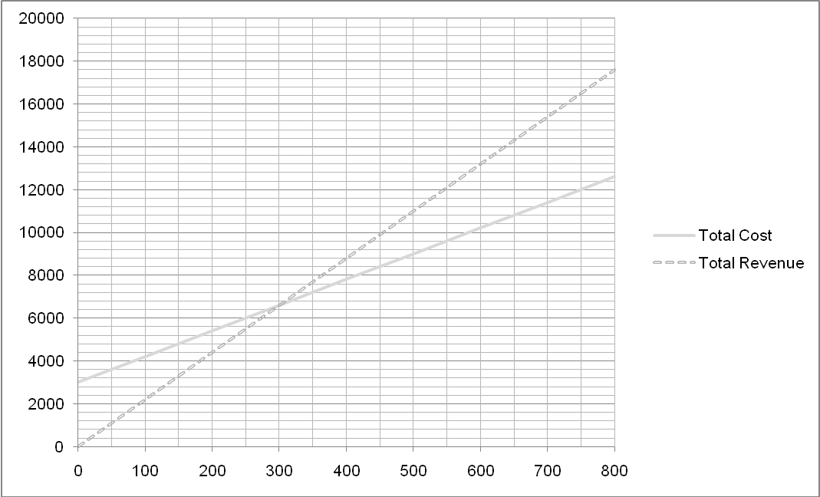

Figure 1 shows Mr Ikitar’s weekly break-even forecast for his new restaurant Strictly Sushi.

- a) What are his forecast fixed costs? (1 mark)
__________________________________________________________________

b) What is his forecast break-even point? (1 mark)
__________________________________________________________________

c) If his market research proves correct and he attracts 500 customers per week what will his profit be? (2 marks)
__________________________________________________________________
__________________________________________________________________
__________________________________________________________________

- Unfortunately his forecasts prove inaccurate and his fixed costs rise by £1000

a) Amend the break-even chart to show Mr Ikitar’s new total cost line. Label this TC2.
(2 marks)

b) Show his new margin of safety if he achieves 500 customers. Label this MS. (2 marks)

c) Show the difference in profit as a result of the increase in fixed costs. Label this P2. (2 marks)

