Break-even charts and break-even analysis
Name: ___________________ Target: _____
Stayfresh Bakeries bakes bread and sells it to wholesalers. On average, each loaf is sold for 50p. Figure 9 shows production in millions of loaves of bread.
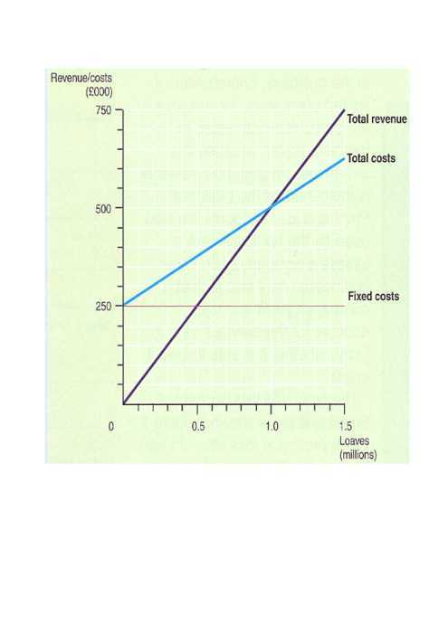

1. What is the break-even point of sales? (1)
__________________________________________________________________________________________________
2. What is the current margin of safety (in quantity of loaves) if production is 1.2 million loaves? (1)
__________________________________________________________________________________________________
__________________________________________________________________________________________________
3. How much profit is the business currently making? (3)
__________________________________________________________________________________________________
__________________________________________________________________________________________________
__________________________________________________________________________________________________
__________________________________________________________________________________________________
__________________________________________________________________________________________________
Draw the axes for a break-even chart running from 0 to 1.5 million loaves on the horizontal axis and 0 to £750,000 on the vertical axis, use graph paper.

4. Stayfresh Bakeries gives its staff a pay rise and buys new machinery. This increases fixed costs by £50 000 a year. Plot the new fixed cost line on your diagram. (1)
__________________________________________________________________________________________________

5. The cost of flour goes up. This increases the variable cost of a loaf of bread by 8% from 25p per loaf to 27p per loaf. Plot the new total cost line on your diagram. (1)
__________________________________________________________________________________________________

6. Stayfresh Bakeries increases its prices by 4%, from 50p per loaf to 52p per loaf to cover these increases in costs. Plot the new revenue line on your diagram. (1)
__________________________________________________________________________________________________
8. What has happened to (a) the break-even point and (b) to profit on 1.2 million loaves? (4)
__________________________________________________________________________________________________
__________________________________________________________________________________________________
__________________________________________________________________________________________________
__________________________________________________________________________________________________
__________________________________________________________________________________________________
__________________________________________________________________________________________________
__________________________________________________________________________________________________
__________________________________________________________________________________________________
7. The aim of the company is to make £50,000 profit per year. One way is to increase the price of the bread sold and the other is to reduce the cost of the raw materials being used by sourcing a cheaper supplier. Which of these choices do you think is the most appropriate to reach the target profit level? Justify your answer. (6)
__________________________________________________________________________________________________
__________________________________________________________________________________________________
__________________________________________________________________________________________________
__________________________________________________________________________________________________
__________________________________________________________________________________________________
__________________________________________________________________________________________________
__________________________________________________________________________________________________
__________________________________________________________________________________________________
__________________________________________________________________________________________________
__________________________________________________________________________________________________
__________________________________________________________________________________________________
__________________________________________________________________________________________________
__________________________________________________________________________________________________
__________________________________________________________________________________________________
__________________________________________________________________________________________________
__________________________________________________________________________________________________
__________________________________________________________________________________________________
__________________________________________________________________________________________________
__________________________________________________________________________________________________
__________________________________________________________________________________________________
