COSTS, REVENUE AND BREAKEVEN ANALYSIS NAME:

1. Which of the following would be used in Gillens Ltd when producing a breakeven chart? 1 mark

- cash flow forecast
- units of production
- articles of Association
- profit and loss account

2. Raw materials bought by Gillens Ltd to make bears are _____ costs. 1 mark

- fixed
- total
- capital
- variable

3. Costs that stay the same are known as: 1 mark

- variable costs
- profit
- fixed costs
- loss

4. Which of these is a fixed cost? 1 mark

- Production workers’ wages
- Travel costs
- Raw materials
- Rent

5. Which of these is a formula for calculating revenue? 1 mark

- Fixed costs + variable costs
- Quantity sold x selling price
- Actual output – breakeven output
- Total revenue – total costs

6. What is meant by the breakeven point? 2 mark

TASK 2: Match the term with the correct formula by moving the boxes: 6 marks
Selling Price per unit – Variable costs per unit
Sales Revenue
Variable costs per unit x quantity
Contribution
Fixed costs / contribution
Total Variable costs

Selling Price per unit – Variable costs per unit
Margin of Safety

Breakeven point
Actual output – Breakeven output

Total Costs
Fixed costs + total variable costs

TASK 3: For each of the costs below, indicate whether it is fixed or variable. 11 marks

COST | FIXED (F) | VARIABLE (V)
Electricity
Rent
Rates
Loan repayments
Salaries
Insurance payments
Advertising
Raw materials
Power
Water bill
Machinist’s wages

TASK 4 Box Coats Ltd manufactures wax jackets in a small factory on the outskirts of Liverpool. Their sole customer is a major UK chain store, which purchases 1000 jackets per month. The company charges the chain store £40 per jacket. 14 marks

Fixed costs per month:
Rent 1400
- Total fixed costs are:
Rates 800
Salaries 9000
Other costs 800

The manufacture of each jacket costs
b) Total variable costs are:
Materials 12.00
Labour 13.00

2 marks

c) Using the information given above on Box Coats Ltd complete the table below: 5 marks

Quantity of jackets | Fixed costs | Variable costs | Total costs | Total revenue | Profit/loss
0
100
200
300
400
500
600
700
800
900
1000

e) What is the breakeven point? 1

f) What is the revenue at breakeven? 1

Check this is correct by using the breakeven formula calculate the number of jackets the Box Coats needs to sell to breakeven. Show your workings. 3 marks

g) What is the margin of safety if the business produces and sells 1000 jackets? Show your workings. 2m

TASK 5: a. Fully label the breakeven chart below: 10marks

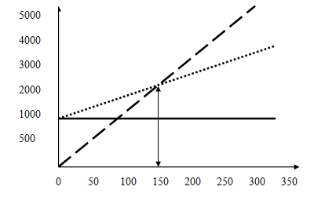

b. How many units need to be sold to breakeven?

c. Draw the margin of safety on the graph if the business makes and sells 250 units.

TASK 6: Boxall Ltd sell boxes for £2 each and have fixed costs of £120,000 and variable costs per unit are £0.50. Complete the table below: 10 marks

Sales | Price | Total revenue | Total fixed cost | Variable cost | Total variable cost | Total cost | Profit/loss
20000
40000
60000
80000
100000

- Shade the point at which Boxall breakeven on the table.

- Check this using the formula for calculating breakeven.
Show your workings.

TASK 7: MULTI-CHOICE QUESTIONS 3 marks
1. A bookseller sells 1,000 books a month at an average price of £10 each. At the same time, the bookseller buys in 1,000 books a month at an average cost of £7 each. Buying books is the only cost which changes each month for the bookseller. Which one of the following is correct? Select one answer. Per month, total revenue is
A £100 whilst fixed costs are £70
B £990 whilst fixed costs are £993
C £1,000 whilst variable costs are £70
D £10,000 whilst variable costs are £7,000

2. Figure 8 shows a break-even chart for a business. The business is currently selling 15 million nuts at a price of 0.5p each. What is its margin of safety at this level of sales? Select one answer.
A 15 million sales
B 5 million sales
C £75,000
D £25,000

3. Figure 8 shows a break-even chart for a business. The fixed costs of the business rise from £40,000 to £60,000. What is the new break-even level of output of nuts? Select one answer.
A 5 million
B 10 million
C 15 million
D 20 million

TASK 8: MISSING WORD ACTIVITY 8 marks

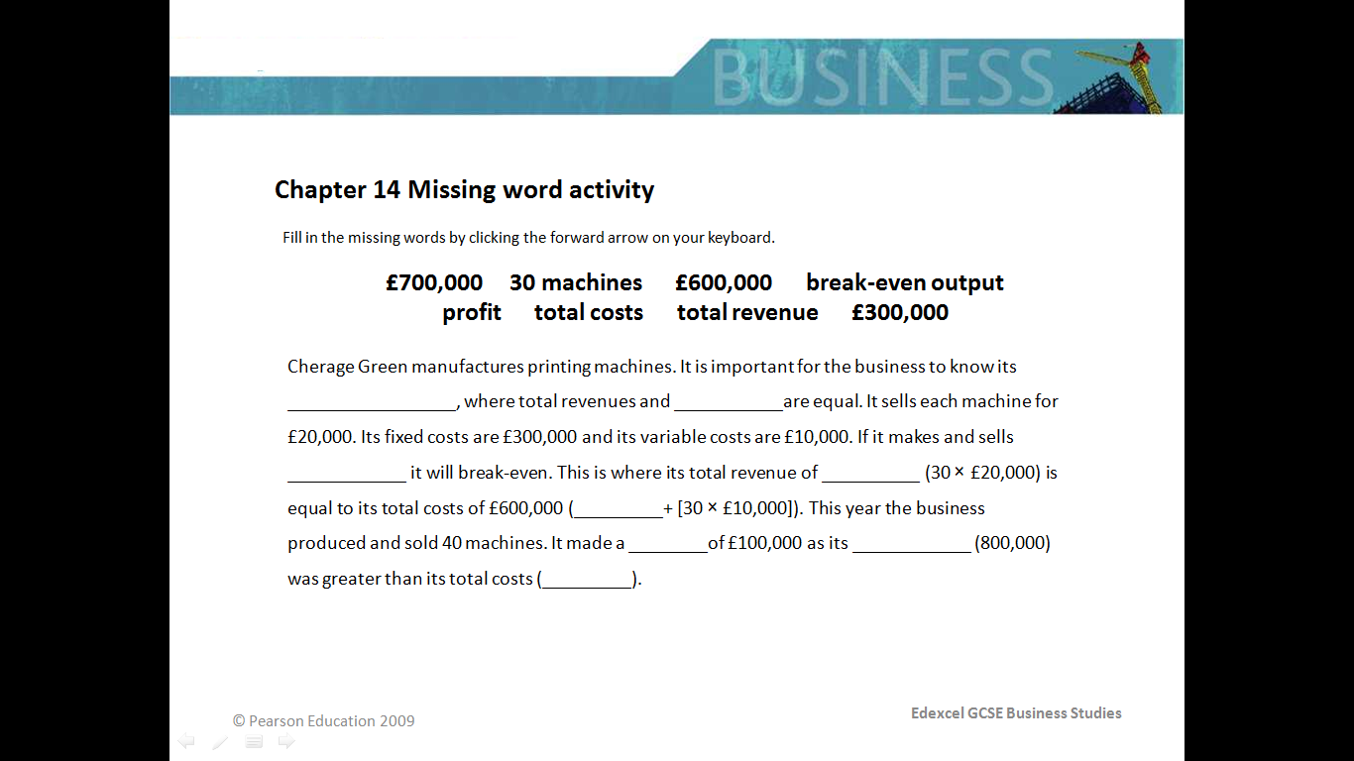

Cherage Green manufactures printing machines. It is important for the business to know its _________________________, where total revenues and ________________ are equal. It sells each machine for £20,000. Its fixed costs are £300,000 and its variable costs are £10,000. If it makes and sells ________________ it will breakeven. This is where its total revenue of ________________ (30 x £20,000) is equal to its total costs of £600,000 (________________ + [30 x £10,000]). This year the business produced and sold 40 machines. It made a ______________ of £100,000 as its _____________ (9800,000) was greater than its total costs (______________).

TASK 9: Complete the table below stating the advantages and disadvantages of business using breakeven analysis as a decision making tool. Use your own knowledge, active book or any other source. 6 marks

BREAKEVEN ANALYSIS
ADVANTAGES | DISADVANTAGES

