ACTIVITY 2

A solicitors firm has chosen the following software to install on their computers:

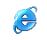
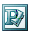
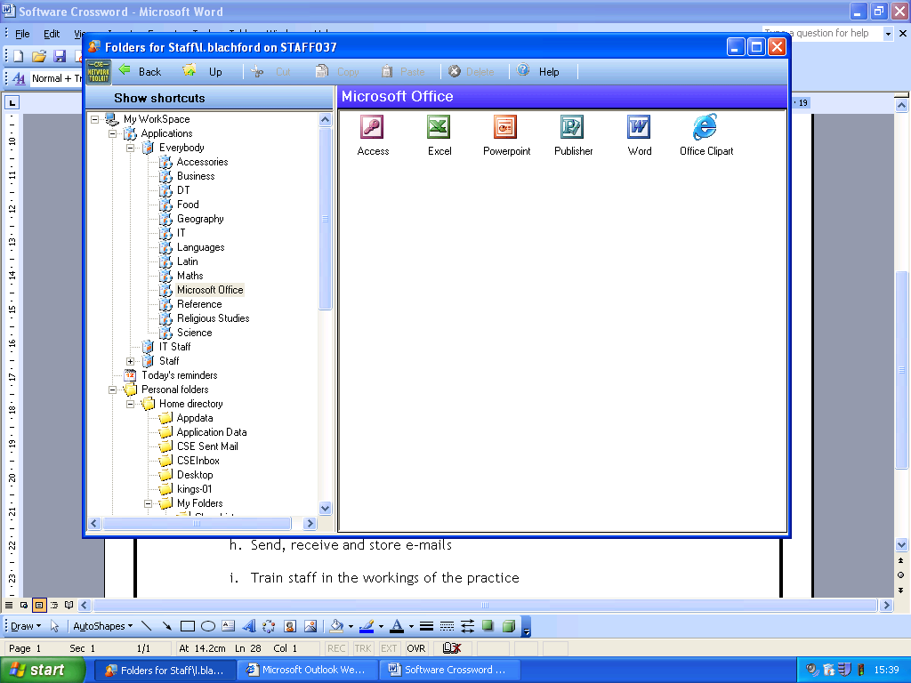


Dreamweaver Word Excel Outlook PowerPoint Access Internet Explorer Publisher

Listed below are tasks that the solicitors have to do. For each of the tasks, suggest which of the software listed above would be most suitable. You can use the Microsoft website to find out about the separate packages and what they do (if you need to). The website address is: www.microsoft.com

 | Task | Software
a | Create letters & documents for clients
b | Create invoices to send to clients
c | Prepare accounts
d | Keep a database of clients’ names and addresses
e | Produce a leaflet showing their services, including images and text
f | Send, receive and store e-mails
g | Create a presentation to train staff in the workings of the practice
h | Research topics that they are currently working on
i | Produce graphs and charts to show changes over time in performance/income
J | Create a website giving customers information about their services

ACTIVITY 1

What software am I?
y

