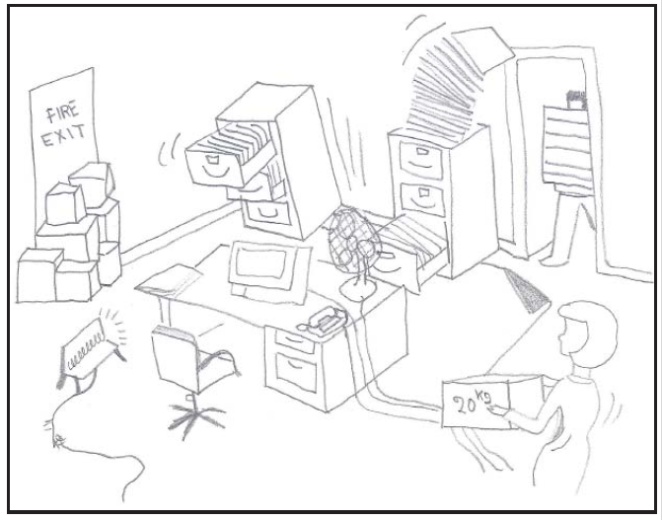
Health and safety hazards

1.
10

2
9

3
8

4
7
6
5

