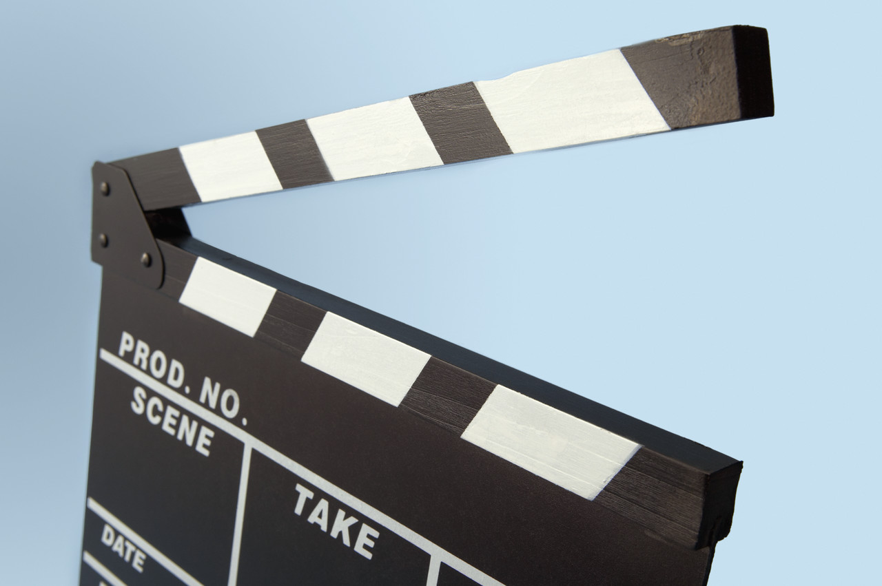
MOVIE MAKER EVALUATION

What was good about my movie? Did you meet the aims set out in your planning?

What I liked about movie maker

Who was the audience for my movie?

How did I make my movie suitable for this audience?

What I would do to make my movie better

Conviscated

